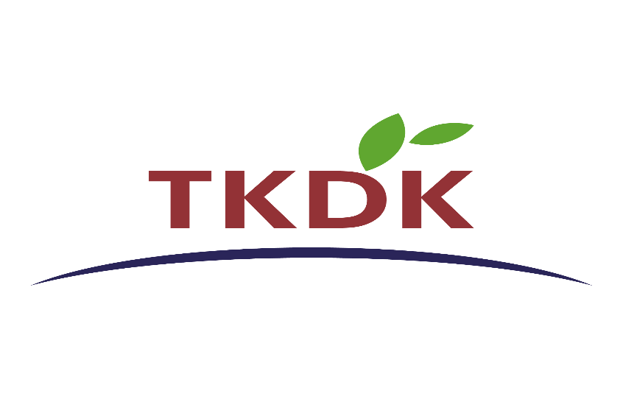
Republic of Türkiye

AGRICULTURE AND RURAL DEVELOPMENT SUPPORT INSTITUTION

TÜRKİYE AGRIFOOD SECTOR TRANSFORMATION for RURAL JOBS AND GROWTH (TARGET) PROJECT
(P514478)

STAKEHOLDER ENGAGEMENT PLAN (SEP)

August 2026

Table of Contents
List of Tables 3
Abbreviations 4
EXECUTIVE SUMMARY 7
1. INTRODUCTION / PROJECT DESCRIPTION 10
2. PROJECT BACKGROUND 11
2.1. Project Components 11
3. OBJECTIVE / DESCRIPTION OF SEP 12
4. STAKEHOLDER IDENTIFICATION AND ANALYSIS 14
4.1. Methodology 14
4.2. Categorization of Stakeholders 14
4.3. Stakeholder Analysis Matrix 16
5. STAKEHOLDER ENGAGEMENT PROGRAM 24
5.1. Summary of the Stakeholder Engagement Done During Project Preparation 24
5.2. Stakeholder Engagement Plan Public Consultation Meeting (August 4,2026) 25
5.3. Strategy for Information Disclosure 28
5.4. Stakeholder Engagement Plan Aligned with Project Phases 28
5.5. Closing the Feedback Loop and Reporting Back to Stakeholders 31
6. RESOURCES AND RESPONSIBILITIES FOR IMPLEMENTING STAKEHOLDER ENGAGEMENT ACTIVITIES 32
6.1. Implementation Arrangements for Stakeholder Engagement 32
6.2. Roles and Responsibilities Matrix 32
6.3. Budgetary Resources for SEP Execution 35
6.4. Management of the Stakeholder Engagement Database 35
7. GRIEVANCE MECHANISM 36
7.1. GM for Public 37
7.2. GM for Employees 39
7.3. GM for the Management of Sensitive Complaints 40
7.4. Appeals Mechanism 42
8. MONITORING AND REPORTING 44
8.1. Summary of how SEP implementation is monitored and reported 44
8.2. Key Performance Indicators for SEP Audit 44
8.3. Involvement of Stakeholders in Monitoring Activities 47
8.4. Reporting Back to Stakeholder Groups and Lending IFIs 47
9. REVIEW AND UPDATE 48
10. CONTACT INFORMATION FOR PUBLIC 49
11. ANNEXES 50
ANNEX A. Complaint Register Form 50
ANNEX C. Grievance Register Table 52
ANNEX D. – Stakeholder Engagement Log Template 53
ANNEX E. – Contact Information of the PCUs 54
ANNEX F. – Contact Information of the Provincial Contact Offices 56
ANNEX G: Stakeholder Engagement Plan (SEP) Consultation Meeting Minutes 58
ANNEX H: Stakeholder List For The Project Stakeholder Engagement Plan Consultation Meeting 62
ANNEX I: Consultation Meeting Presentations 67
Annex J: Photographs Of The Stakeholder Consultation Meeting (Date: August 4, 2026 / Format: Online) 76

List of Tables

Table 1 – Main Stakeholders for the Project 15
Table 2 – Identified Vulnerable Groups and the Way of Communication 21
Table 3 – Engagement Methods to be Employed under the Project 26
Table 4 – Stakeholder Engagement Program for the Project 29
Table 5 – Roles and Responsibilities 33
Table 6 – Grievance and Feedback Submission Channels available to Public 37
Table 7 – Grievence Response Timelines and Process Steps 38
Table 8 – Grievance and Feedback Submission Channels available to Employees 40
Table 9 – Categories of Sensitive Complaints 41
Table 10 - Key Performance Indicators of the Project Phases 45

Abbreviations
AEs | Agrifood Enterprises
BRSA | Banking Regulation and Supervision Agency
CIMER | Presidency’s Communication Center
ECA | Europe and Central Asia
ESF | Environmental and Social Framework
EIA | Environmental Impact Assessment
EOI | Expression of Interest
E&S | Environmental and Social
ESA | Environmental and Social Assessment
ESCP | Environmental and Social Commitment Plan
ESIA | Environmental and Social Impact Assessment
ESMF | Environmental and Social Management Framework
ESMP | Environmental and Social Management Plan
ESMU | Environmental and Social Management Unit
ESS | Environmental and Social Standard
FGD | Focus Group Discussion
FI | Financial Intermediary
GBV | Gender Based Violence
GCUEF | General Coordination Unit for External Finance
GM | Grievance Mechanism
HQ | TKDK Headquarters
IFI | International Finance Institutions
I-SEP | Institutional Stakeholder Engagement Plan
IPF | Investment Project Financing
KGF | Credit Guarantee Fund
M&E | Monitoring and Evaluation
MoAF | Ministry of Agriculture and Forestry
MoEUCC | Ministry of Environment, Urbanization and Climate Change
MoFSS | Ministry of Family and Social Services
MoLSS | Ministry of Labor and Social Security
MoTF | Ministry of Treasury and Finance
MPA | Multiphase Programmatic Approach
NGO | Non-Governmental Organization
OHS | Occupational Health and Safety
PAP | Project Affected People
PCG | Partial Credit Guarantee
PCU | Provincial Coordination Units
PFI | Participating Financial Institutions (protocol banks acting as individual commercial underwriters)
PIU | Project Implementation Unit
POs | Producer Organizations
RFF | Reimbursement Finance Facility
SBO | Presidency’s Strategy and Budget Office
SEA | Sexual Exploitation and Abuse
SEGE | Socio-Economic Development Ranking
SEP | Stakeholder Engagement Plan
SH | Sexual Harassment
TARGET | Türkiye Agrifood Sector Transformation for Rural Jobs and Growth Project
TKDK | Agriculture and Rural Development Support Institution
ToR | Terms of Reference
YIMER | Foreigners Communication Center

EXECUTIVE SUMMARY
Project Background and Operational Context
The Türkiye Agrifood Sector Transformation for Rural Jobs and Growth Project (TARGET) is a World Bank-financed initiative implemented by the Agriculture and Rural Development Support Institution (TKDK) under the overall supervision of the Ministry of Agriculture and Forestry (MoAF).
Under the first phase of the project's overall USD 2 billion credit line, an agreement has been reached for USD 720 million to be provided, reimbursable foreign-currency financing, alongside USD 30 million allocated as credit guarantee support through the Portfolio Guarantee System in cooperation with the Credit Guarantee Fund (KGF).
The project, funded by the World Bank, consists of two components. The first component provides reimbursable support in foreign currency and with a long term. The second component targets contract farmers engaged in initial production, and a guarantee rate will be applied to reduce the difficulties they face in accessing existing finance. A resource allocation of USD 30 million has been made for these capacity guarantee rates.
The World Bank project supports the development of agricultural-food businesses and essential agricultural and livestock services within the framework of a value chain financing model.
The project requires the implementation of World Bank Environmental and Social Standard 10 (ESS10: Stakeholder Engagement and Information Disclosure), which mandates the systematic and comprehensive expansion of the scope of public disclosures and general information disclosures throughout the project.
Regulatory Alignment and Gap-Filling Strategy
The Stakeholder Engagement Plan aims to bridge the gaps between national legislation in Turkey, including the constitutional provisions on the right to petition and access to information, the Right to Information Act, and the national Environmental Impact Assessment (EIA) Regulation, and the additional requirements stipulated under the World Bank Environmental and Social Standard 10.

Stakeholders are systematically classified as Project Affected Parties, encompassing agricultural-food businesses, primary producers, local communities, and direct or contracted agricultural labor, and Other Interested Parties, encompassing the Ministry of Treasury and Finance, the Ministry of Labour and Social Security, the Ministry of Environment, Urbanization and Climate Change, relevant regional directorates, municipalities, commodity exchanges, academic institutions, and Ziraat Bank acting as an intermediary bank.

Stakeholder engagement activities are initiated in the early stages of the sub-project development process, not after the completion of legal application processes. Public disclosure periods are before the final evaluation and contract signing; Environmental and social risk assessment is applied for at least 10 calendar days for sub-projects classified as "Medium Risk" within the scope of the Environmental and Social Management Plan, and at least 20 calendar days for sub-projects classified as "Significant Risk" within the scope of the Environmental and Social Impact Assessment, Stakeholder Participation Plan, and Resettlement Plan.

In addition, the establishment of employee complaint mechanisms that guarantee confidentiality at the field level and provide protection against retaliation is mandatory for all workforce categories. Furthermore, it is possible to submit completely anonymous complaints from both the public and employees.

Targeted Engagement Strategy for Vulnerable Groups

To reduce barriers to participation in remote areas and priority development levels, the Agricultural and Rural Development Support Institution (TKDK) implements targeted and differentiated stakeholder outreach strategies.
To reach small-scale producers in remote areas, mobile information activities are carried out by TKDK Provincial Coordination Units personnel; simplified call documents and application guides are physically distributed through district agricultural directorates, village headmen, and coffee houses.
Separate information meetings are organized for female producers, conducted by female personnel and planned taking local conditions into account; these meetings provide information on training needs and financial products.
Information activities for young entrepreneurs are carried out through digital communication efforts and explanatory visual content introducing the flexible creditworthiness criteria applied in priority regions.
Beneficiaries and contractors employing seasonal or migrant workers are obliged to provide information on working conditions, occupational health and safety risks, and access to the complaint mechanism in a language that employees can understand and, where necessary, in their native languages, supported by simplified Code of Conduct documents.
Information activities targeting individuals with low literacy levels, elderly stakeholders, and people with disabilities are carried out through non-technical and visually oriented brochures, the TKDK Help Desk (444 85 35), accessible information areas, information materials prepared in easy-to-read or audio formats, and individual field visits conducted by the Provincial Coordination Units staff.
Grievance Mechanisms
Within the scope of the project, a multi-layered and transparent Complaint Mechanism is implemented, accessible through multiple application channels including the TKDK website, official e-mail addresses, telephone line (444 85 35), physical mail, locked complaint boxes located in TKDK Central and Provincial Coordination Offices, CİMER (150) and YİMER (157). In addition, employee complaint boxes, accessible independently of management levels and with confidentiality guaranteed, will be provided in the sub-project areas.
Complaints are recorded by the Provincial Coordination Office Social Focal Points on the day of receipt, a confirmation of receipt is given to the applicant within 2 working days, and an official written response is provided within 15 working days.
Applications that cannot be resolved at the provincial level are transferred to the Central Environmental and Social Management Unit for independent review; a final institutional decision is made within an additional 15 working days.
In sensitive applications concerning gender-based violence, sexual exploitation and abuse, and sexual harassment, victims will be promptly referred to relevant public support services, independent expert support will be provided, the principle of complete confidentiality will be maintained, and notifications to the World Bank will be made within the specified timeframes.
Allegations of fraud or corruption will be forwarded directly to the Legal Counsel or Internal Audit Coordination Office.
Under Component 2, participating banks will manage loan application requests within their own institutional mechanisms; however, they will be obliged to forward all environmental and social complaints related to the project to TKDK within a maximum of 3 business days. Applications submitted under this scope will be finalized within 30 days.

INTRODUCTION / PROJECT DESCRIPTION

Türkiye Agrifood Sector Transformation for Rural Jobs and Growth (TARGET) Project (P514478), implemented by the Ministry of Agriculture and Forestry (MoAF) of the Republic of Türkiye through the Rural Development Support Institution (TKDK), aims to boost jobs, incomes, competitiveness, and climate resilience in the agrifood sector by addressing chronic underinvestment in technology and infrastructure and address value chain coordination failures. The project operationalizes ECA-Agriconnect MPA approach (P518183) seeking to transform smallholder farming, create jobs, and strengthen global food security.
The TARGET Project will address agrifood sector coordination and financing constraints through a complementary set of downstream and upstream interventions. The Project will support mid-cap agrifood enterprises (AE) and producer organizations (PO) as anchor firms to drive value chain upgrading and strengthen supply chain coordination. Through reimbursable financing, the Project will incentivize investments in production, processing, logistics, quality and traceability systems, and structured sourcing arrangements with farmers, particularly in less developed regions. These investments will help address coordination externalities by aligning incentives across value chain actors, reducing post-harvest losses, improving product quality and reliability, and strengthening the integration of smallholders into formal markets. The Project will also introduce a risk-sharing mechanism to address credit market imperfections by improving the risk-return profile of agricultural lending. By partially mitigating credit risks, the facility will incentivize financial institutions to expand lending to farmers that are credit worthy but cannot fully meet banks’ collateral requirements, enabling them to access finance for both working capital but particularly for critical, on-farm investments in productivity-enhancing technologies and climate-resilient practices. The partial credit guarantee (PCG) will target farmers that are supplying AE and PO supported through reimbursable finance to enable an integrated value chain finance and upgrading strategy.
Together, these interventions are expected to crowd in private investment, strengthen coordination across value chains, and expand access to finance. Downstream investments will enhance value addition, efficiency, expand capacity, and market access, while upstream financing will support productivity gains and resilience at the farm level. These combined effects are to increase sector competitiveness, support enterprise growth, and generate employment in agro-processing, logistics, and related services – particularly for women and youth. Improved integration of farmers into formal supply chains, alongside greater access to finance, is to raise farm productivity and incomes. Over time, these outcomes will contribute to export expansion, greater domestic market sophistication, reduced regional disparities, and enhanced economic resilience.
The TARGET Project is being prepared in accordance with the World Bank’s Environmental and Social Framework (ESF), which requires compliance with the Environmental and Social Standards (ESSs). In accordance with the ESF, a suite of environmental and social instruments has been prepared for TARGET Project to assess and manage potential environmental and social risks and impacts associated with Project activities. These instruments include the Environmental and Social Commitment Plan (ESCP) and Stakeholder Engagement Plan (SEP), and other environmental and social instruments prepared as required under the ESF.
This SEP has been prepared in line with ESS10 on Stakeholder Engagement and Information Disclosure. It establishes the framework for meaningful, continuous, and inclusive engagement with project-affected parties and other interested stakeholders throughout the Project lifecycle. The SEP defines stakeholder identification and analysis, information disclosure, consultation and participation mechanisms, grievance management procedures, implementation responsibilities, and monitoring arrangements. The SEP applies to all investments financed under TARGET Project and will be updated periodically, as necessary, to reflect Project developments and evolving stakeholder engagement needs.

2. PROJECT BACKGROUND

Türkiye’s agrifood sector serves as a socio-economic cornerstone, contributing significantly to national gross domestic product (GDP), employment, and regional food security. However, the sector faces persistent structural constraints. Fragmented supply chains, low modernization rates, high post-harvest losses, and a pronounced shortage of medium- and long-term commercial investment capital limit sectoral growth, particularly in economically lagging regions. These structural vulnerabilities are further amplified by severe climate change impacts, manifesting as systemic water scarcity, erratic precipitation patterns, heat stress, and volatile raw material yields.
The agrifood sector continues to experience structural constraints that limit its competitiveness and ability to generate high-quality employment opportunities. Agrifood enterprises (AEs) and producer organizations (POs) play a critical role in processing, marketing, and integrating smallholders into formal value chains. However, many face limited access to finance, inadequate infrastructure, insufficient capacity for technological upgrading, and difficulties meeting market and certification requirements. These constraints contribute to low value addition, post-harvest losses, weaker market access, and reduced opportunities for job creation.
Access to affordable long-term financing remains one of the most significant barriers to agrifood sector modernization in Türkiye. Farmers, AEs, and POs largely rely on short-term financing, which restricts investments in productivity-enhancing technologies, climate-smart practices, processing facilities, storage, logistics, and value chain development. The availability of long-term investment financing has declined in recent years due to funding structure constraints within the banking sector, high perceived risks in agriculture, and broader macroeconomic conditions.
The Government of Türkiye has prioritized agrifood sector transformation through the Twelfth Development Plan (2024-2028), the Agricultural Production Planning Model (2025), and initiatives aimed at strengthening agro-industrial integration, improving productivity, enhancing climate resilience, and promoting regional development. Achieving these objectives requires greater mobilization of private investment alongside public support mechanisms.
The proposed project will support the Government’s efforts to modernize the agrifood sector by improving access to long-term finance, strengthening value chain linkages, promoting climate-resilient and productivity-enhancing investments, and facilitating greater participation of smallholders in formal markets. The project will support agrifood enterprises, producer organizations, and farmers in undertaking investments that improve competitiveness, sustainability, and job creation, particularly in less developed and vulnerable regions. The project will also pilot and scale innovative financial instruments that leverage private sector financing and address key market barriers limiting investment in the agrifood sector.
The project is aligned with the World Bank Group’s Türkiye Country Partnership Framework (FY24-FY28), the World Bank’s AgriConnect approach, and Türkiye’s climate and development priorities. It is expected to contribute to sustainable productivity growth, enhanced climate resilience, increased inclusion of women and youth, and the creation of better employment opportunities across the agrifood sector.

Project Components
The TARGET Project comprises the following components:
- Component 1: Reimbursable Finance for Agrifood Sector Modernization & Inclusion
Component 1 supports mid-size enterprises and mid-cap agrifood enterprises (AE) and producer organizations (PO) as anchor firms to drive value chain upgrading and strengthen supply chain coordination through establishing a Reimbursable Financing Facility (RFF). Moving beyond traditional matching grant frameworks, the RFF introduces a fiscally disciplined, recycling model of Project financing mechanism concessional financing. This facility targets medium-sized enterprises, eligible mid-caps, and registered producer organizations (POs) to catalyze capital investments in value-chain upgrades. Funded investments encompass hub-and-spoke logistics corridors, standardized aggregation hubs, cold-chain systems, digital traceability platforms, and strict food safety compliance infrastructure.
Crucially, the facility targets economic multipliers by prioritizing investments located in, or substantially sourcing from Priority regions defined under the Project. Supported enterprises will act as critical market anchors, directly developing and integrating primary producers and smallholders through contract farming, supplier-linked technical advisory support, and inputs pre-financing modules.
- Component 2: Strengthening the Financial Ecosystem for the Agrifood Sector
Component 2 establishes a local currency Partial Credit Guarantee (PCG) scheme operationally managed via the Credit Guarantee Fund (KGF). The PCG facility operationally de-risks commercial lending to primary farmers supplying the RFF ecosystems, mitigating strict collateral constraints and reinforcing integrated financial outreach along the entire value chain.
Operationally, Component 2 provides a critical mechanism for risk-sharing with commercial finance markets. By targeting primary farmers – especially smallholders, women, and youth who traditionally fall outside standard commercial lending risk appetites. The PCG bridges the gap between primary production and downstream agrifood modernization. Stakeholder outreach for Component 2 will therefore be delivered concurrently with Component 1 calls to maximize ecosystem integration, ensuring that primary producers can access the credit lines needed to fulfill supply-chain commitments with RFF-supported anchor enterprises.
- Component 3: Project Management, Monitoring and Evaluation (M&E)
Component 3 covers TKDK’s project management, fiduciary and E&S compliance needs, including PIU (Central level) and PCU (Provincial level) operating costs. It also supports capacity building for TKDK for project implementation and M&E aspects.

3. OBJECTIVE / DESCRIPTION OF SEP
Stakeholder engagement is a continuous, inclusive, and adaptive process that must be conducted throughout the entire lifecycle of a project – from preparation through implementation, commissioning, and into the early operational period. It is not a compliance exercise conducted at a single point in time, but an ongoing commitment to transparency, dialogue, and responsiveness. When properly designed and implemented, stakeholder engagement supports the establishment of strong, constructive, and sensitive working relationships that are essential for the successful management of a project’s environmental and social risks and impacts, and for the long-term sustainability of its outcomes.

The overarching purpose of this SEP is to establish the stakeholder engagement framework, communication mechanisms, and implementation arrangements necessary to facilitate effective interactions among TKDK, project beneficiaries, affected communities, and other relevant stakeholders throughout Project implementation. Building on the principles and approaches set out in the TKDK Institutional Stakeholder Engagement Plan (I-SEP), this SEP translates those institutional commitments into a practical, project-specific engagement strategy tailored to the operational context, activities, and stakeholder landscape of the TARGET Project.
The SEP is both a planning document, identifying who will be engaged, how, and when, and an accountability mechanism that sets measurable commitments for the PIU and its consultants and contractors. It is also a living document, expected to be updated as the Project develops, as new information becomes available, and as stakeholder needs and concerns evolve.
This SEP provides a framework to support the establishment of a continuous engagement process between the management and those who potentially would be impacted by or have any kind of interest in the Project (stakeholders). Besides, it will also help to manage stakeholder expectations and support the management of risks and therefore reduce potential conflicts and project delays by providing early, frequent and open communication throughout the life of the project.
The key objectives of the Stakeholder Engagement Plan (SEP) can be summarized as follows:
- To establish a systematic and structured approach to stakeholder engagement that enables the PIU to identify all relevant stakeholders, assess their interests and concerns, and build and maintain constructive relationships throughout the Project lifecycle with particular priority given to project-affected parties (PAPs),
- To assess the level of stakeholder interest, awareness, and support for the Project and to ensure that the views, concerns, and knowledge of stakeholders are taken into account in project design, planning, and implementation decisions, and in the ongoing management of environmental and social performance,
- To promote and provide means for effective and inclusive engagement with project affected parties throughout the Project life cycle on broader issues of community development and inclusion beyond specific sub-project issues,
- To ensure that technically sound and culturally appropriate project information on environmental and social risks and impacts is disclosed in a timely, understandable, accessible, and appropriate manner and accessible formats for vulnerable groups,
- To provide project-affected parties and the general public with accessible and inclusive means to raise issues, concerns, and grievances, and to ensure that the PIU responds to and manages such grievances in a transparent, fair, and timely manner,
- To ensure meaningful participation of disadvantaged and vulnerable groups – including women, persons with disabilities, the elderly, smallholders in remote districts, women-led agribusinesses, youth entrepreneurs, and seasonal agricultural laborers – in all consultation and engagement processes, through dedicated and appropriately designed activities.
- To create a feedback loop between stakeholders and the Project, ensuring that information gathered through engagement activities is systematically recorded, analyzed, and reflected in adaptive management decisions.
- To comply with the requirements of World Bank Environmental and Social Standard 10 (ESS10) on Stakeholder Engagement and Information Disclosure, as well as applicable Turkish legislation on public participation, access to environmental information, and data protection.
By formalizing these elements, the SEP aims to minimize implementation risks, prevent localized social conflicts, enhance private sector investment readiness, and ensure that the economic benefits of the project are distributed equitably across Türkiye’s agricultural landscapes.

STAKEHOLDER IDENTIFICATION AND ANALYSIS

Methodology
To meet the requirements of World Bank ESS10 and with international best practices and to establish a meaningful stakeholder engagement framework, a structured, evidence-based, and iterative approach to stakeholder identification and analysis process has been conducted. Stakeholders are identified as individuals, groups, or institutions who are either directly impacted by the project rollout or possess a regulatory, commercial, or public interest in its execution.
The evaluation relies on the following key principles to optimize communication and foster strong, collaborative partnerships:
- Inclusiveness and Sensitivity: Stakeholder identification is designed to be comprehensive and to enhance communication across all affected groups. The engagement process is inclusive, ensuring equal access to information and consultation opportunities. Special attention is given to vulnerable and disadvantaged groups to ensure their needs are met and their voices are heard on an equal footing with other stakeholders.
- Openness and Life-Cycle Approach: Public consultations are conducted throughout the project lifecycle to maintain transparency and engagement. Consultations are designed to be open and inclusive, ensuring that all stakeholders can freely express their views without any external manipulation, interference, coercion, or intimidation. Engagement will not cease after project approval or the commencement of construction, it will continue through commissioning and into the early operational period.
- Informed Participation and Feedback: Information is shared in accessible formats and languages to ensure stakeholders are fully informed about the Project’s scope, objectives, and potential impacts before being asked for their views. Feedback mechanisms are established to ensure stakeholders have the opportunity to provide input and receive timely and substantive responses to their concerns.
- Transparency and Accountability: Stakeholders are provided with regular updates on project progress, potential risks, and mitigation measures. The grievance mechanism provides a formal and accessible channel for stakeholders to raise concerns and receive timely resolutions. All engagement activities are documented and reported publicly.
- Cultural Appropriateness: Engagement activities are designed and conducted with full awareness of the cultural, linguistic, and social context of each project province. In provinces with high population of minority language populations, engagement materials and facilitators will reflect these linguistic needs.

Categorization of Stakeholders
In accordance with ESS10, project stakeholders are classified into three primary operational categories:
4.2.1 Project-Affected Parties (PAPs)
These are individuals, groups, and business entities that are directly exposed to the operational, economic, environmental, or social impacts stemming from the implementation of the Reimbursable Financing Facility (RFF) under Component 1 or the Partial Credit Guarantee (PCG) scheme under Component 2:
- Agrifood Enterprises (AEs) and Producer Organizations (POs): Medium-sized enterprises, eligible mid-caps, and cooperatives, producer organizations operating within the eligible value chains defined under the Project who secure concessional funding through the RFF to modernize processing lines, build logistics nodes, or upgrade cold storage infrastructure. In the event that subsequent funding windows expand eligible expenditures to include broader civil works for agrifood enterprise modernization, all corresponding local communities and landholders in those prospective investment areas will automatically be integrated into the PAP category.
- Primary Producers and Smallholder Farmers: Agricultural households and registered farmers who supply raw materials to supported anchor firms, or who utilize the PCG scheme to access commercial credit for on-farm modernization and climate-resilient upgrades.
- Agricultural Labor Force: Direct employees, contracted construction workers, and seasonal agricultural laborers engaged at sub-project construction sites or within the expanded processing operations of beneficiary enterprises.
- Local Communities and Neighborhoods: Residents and neighborhood heads (mukhtars) located immediately adjacent to RFF-funded infrastructure footprints, who may experience temporary construction-related disturbances or localized environmental impacts.
4.2.2 Other Interested Parties
These are institutional actors, regulatory agencies, non-governmental bodies, and civil society organizations who do not sustain direct impacts from sub-project operations but possess a structural, political, or thematic interest in the project’s execution:
- National Public Authorities: Key ministries responsible for policy formulation and environmental permitting, including the Ministry of Treasury and Finance (MoTF), the Presidency’s Strategy and Budget Office (SBO), the Ministry of Labor and Social Security (MoLSS), Ministry of Family and Social Services (MoFSS) and the Ministry of Environment, Urbanization and Climate Change (MoEUCC).
- Provincial and District Directorates: Regional offices of the Ministry of Agriculture and Forestry (MoAF) and MoEUCC, relevant municipalities, special provincial directorates and organized industrial districts who oversee administrative approvals, project monitoring, and localized environmental compliance.
- Financial Intermediary Partners: The Credit Guarantee Fund (KGF) acts as the operational manager for the local currency PCG scheme under Component 2. Alongside KGF, the participating commercial and participation banks that sign formal operational protocols with KGF serve as key institutional stakeholders. Their interest centers on risk-sharing frameworks, leverage capabilities, and compliance with credit screening criteria.
- Routing Intermediary: Ziraat Bank functions as the sole transaction-routing and payment execution agent under Component 1. It operates as an off-balance-sheet intermediary. It does not bear credit risk but physically executes capital disbursements to beneficiaries and manages the collection of loan repayments into the recycling revolving fund.
- Accredited Guarantee-Provider Banks: Licensed banks meeting TKDK criteria to issue and manage unconditional and irrevocable guarantee instruments for approved RFF beneficiaries in accordance with applicable Project procedures.
- Sectoral Associations and Chambers: The Union of Chambers and Commodity Exchanges of Türkiye (TOBB), the Turkish Exporters Assembly, specialized commodity exchanges, and provincial chambers of commerce and industry.
- Civil Society and Academic Institutions: Environmental and agricultural NGOs (e.g., TEMA, WWF Türkiye), local city councils, university agriculture departments, and specialized subject-matter experts.
- National and Local Media: The official TKDK website will serve as the primary and authoritative platform for project information disclosure and public communication. Key project documents, financing opportunities, calls for proposals, environmental and social instruments and project updates will be published on the website. TKDK's official social media accounts, press releases, and national and local newspapers, television, and online news platforms will complement the website by disseminating major announcements, supporting the disclosure of project information and environmental and social documents, promoting public consultation activities, increasing public awareness, and directing stakeholders to the official TKDK website for comprehensive and up-to-date information. National media will support nationwide outreach, while local media will facilitate communication with stakeholders and potential beneficiaries in the provinces where project activities are implemented.

4.2.3 Disadvantaged and Vulnerable Groups
These are individuals or population segments who face historical, physical, economic, or socio-cultural barriers that place them at a higher risk of exclusion from project benefits or limit their capacity to fully participate in standard public consultation processes:
- Smallholders in Economically Lagging Regions: Small-scale, under-capitalized farmers residing in remote districts classified as Priority regions defined under the Project, who face structural barriers to commercial information and technical financing.
- Women Farmers and Female Entrepreneurs: Women engaged in informal or unpaid family agricultural labor, female-headed rural households, and women-led agribusinesses who face persistent gaps in land ownership, independent income, and direct access to banking services.
- Youth Entrepreneurs and New Entrants: Young agricultural producers and individuals under the age of 40 who lack established credit scores or sufficient asset bases to meet rigid banking collateral demands.
- Seasonal and Migrant Agricultural Laborers: Vulnerable agricultural workers, including non-Turkish speaking migrant populations, who are exposed to heightened risks regarding informal working arrangements, language barriers, and restricted access to workplace grievance channels.
- Low-Literacy Agribusiness Operators: Rural enterprise owners or primary producers who have limited ability to review complex technical specifications, digital application systems, or formal environmental compliance literature.
- Persons with Disabilities (PwDs): While physical and digital accessibility (e.g., wheelchair-accessible venues and screen-reader-compliant portals) are core requirements, the Project recognizes that Persons with Disabilities (PwDs) face broader socio-economic barriers in the agrifood sector. These include limited access to financial literacy, exclusion from formal contract-farming supply chains, and lower rates of formal employment.

Stakeholder Analysis Matrix
The following Table 1 provides a detailed analysis of the expected impacts, relevance, interest levels, and influence structures for the main stakeholder categories identified above:
Table 1 – Main Stakeholders for the Project
Stakeholder Category | Description / Specific Actor | Aligned Component | Potential Interest & Projected Project Impact | Level of Interest | Level of Influence
Project-Affected Parties | Agrifood Enterprises & Producer Organizations | Component 1 | AEs and POs are expected to benefit directly from access to affordable, long-term financing to support technological upgrades, productivity improvements, and business modernization. Their primary interests relate to eligibility criteria, application and selection procedures, financing amounts available under the Project, and the technical requirements associated with the proposed investments and infrastructure. | High | Medium to High
Project-Affected Parties | Primary Farmers & Smallholders | Component 1 & 2 | Farmers and smallholders may benefit from improved access to financing opportunities, stronger market linkages, and increased participation in organized value chains. Their primary interests relate to eligibility requirements, access to financial support, application procedures, and opportunities to improve farm productivity and income. | High | Low to Medium
Project-Affected Parties | Direct & Contracted Labor Force | Component 1 | Project workers may benefit from improved employment opportunities, safer working conditions, and strengthened labor management practices. Their primary interests relate to occupational health and safety, fair working conditions, access to grievance mechanisms, and compliance with applicable labor requirements. | Medium | Low
Project-Affected Parties | Affected Local Communities | Component 1 | Local communities may experience temporary impacts during sub-project implementation, such as increased traffic, noise, or dust, while also benefiting from local economic activity and employment opportunities. Their primary interests relate to environmental and social impacts, construction schedules, community health and safety, and access to information and grievance mechanisms. | Medium | Medium
Other Interested Parties | Central and Provincial Authorities Ministries (MoTF, MoAF, SBO, MoLSS, MoFSS MoEUCC), relevant municipalities, special provincial directorates and organized industrial districts | Cross-cutting | National authorities are interested in ensuring that the Project is implemented in accordance with national policies, applicable legislation, and the Project's development objectives. Their primary interests relate to effective implementation, regulatory compliance, environmental and social performance, and achievement of Project results.  Provincial and district authorities play an important role in local coordination, regulatory oversight, and communication with communities. Their primary interests relate to implementation progress, coordination among institutions, compliance with local requirements, and effective stakeholder engagement. | High | High
Other Interested Parties | Credit Guarantee Fund (KGF) | Component 2 | KGF is interested in the effective implementation of the guarantee mechanism in accordance with the Project arrangements. Its primary interests relate to coordination with participating financial institutions, implementation of agreed procedures, and achievement of the Project's financing objectives. | High | High
Other Interested Parties | Ziraat Bank | Component 1 | The designated routing financial institution is responsible for supporting the financial administration of Project transactions. Its primary interests relate to the timely, accurate, and transparent processing of financial transactions in accordance with the Project procedures. | High | High
Other Interested Parties | Participating Financial Institutions | Component 2 | Participating financial institutions are expected to support the delivery of Project financing in accordance with the agreed eligibility and environmental and social requirements. Their primary interests relate to financing procedures, environmental and social compliance, risk management, and efficient loan processing. | Medium to High | Medium
Other Interested Parties | Chambers, Unions, & Commodity Exchanges | Cross-cutting | Sectoral associations and chambers play an important role in informing their members about Project opportunities and supporting outreach activities. Their primary interests relate to promoting sector development, increasing member participation, and facilitating communication between the Project and potential beneficiaries. | Medium | Medium
 | National and Local Media | Cross-cutting | National and local media support public awareness by disseminating Project information and communicating key announcements to a broad audience. Their primary interests relate to timely access to accurate information, transparency, and public communication. | Medium | Medium
Vulnerable / Disadvantaged Groups | Remote Producers (Priority regions defined under the Project) | Component 1 & 2 | Producers in remote or less-developed rural areas may face barriers in accessing Project information and financing opportunities. Their primary interests relate to equal access to Project benefits, clear information, accessible communication channels, and appropriate outreach activities. | High | Low
Vulnerable / Disadvantaged Groups | Women & Youth Producers | Component 1 & 2 | Women farmers and entrepreneurs may face barriers in accessing finance, information, and business opportunities. Their primary interests relate to equal participation, inclusive access to Project support, and measures that encourage women's economic empowerment.  Young entrepreneurs may benefit from opportunities to establish or expand agricultural businesses. Their primary interests relate to access to financing, information on eligibility requirements, business development opportunities, and capacity-building support. | High | Low
Vulnerable / Disadvantaged Groups | Seasonal & Migrant Laborers | Component 1 | Seasonal and migrant workers may face barriers related to language, working conditions, and access to grievance mechanisms. Their primary interests relate to fair treatment, occupational health and safety, accessible communication, and protection of labor rights. | Medium | Low
 | Low-Literacy Agribusiness Operators | Component 1 & 2 | Individuals with limited literacy or digital skills may experience difficulties accessing Project information and application procedures. Their primary interests relate to clear communication, simplified information materials, and accessible support throughout the Project cycle. | Medium | Medium
 | Persons with Disabilities (PwDs) | Component 1 & 2 | Persons with disabilities may face physical, communication, or other barriers to participating in Project activities. Their primary interests relate to accessible information, inclusive consultation processes, equal opportunities to participate, and reasonable accommodation where needed. | Medium | Medium

ESS10 requires that special attention be given to the engagement of vulnerable or disadvantaged groups, recognizing that they may face unique barriers to participation and may be disproportionately affected by project impacts. It is of particular importance to identify and understand these groups early, to assess whether project impacts fall disproportionately on them, and to design engagement activities that genuinely reach them and incorporate their perspectives.
The vulnerable and disadvantaged groups identified during the project preparation phase, the nature of their vulnerabilities, and the measures to be taken to ensure their meaningful participation are presented in Table 2 below.
Table 2 – Identified Vulnerable Groups and the Way of Communication
Vulnerable Groups | Vulnerabilities / Constraints | Special Engagement Needs | Required Support
Producers in Remote and Less Developed Rural Areas | Limited access to information, public services, financial institutions, and consultation activities due to geographic remoteness. | Early and targeted outreach using locally accessible, non-digital, physical communication channels and sufficient time for participation. | Information shared through Provincial Coordination Units (PCUs), local agricultural authorities, village headmen (mukhtars), community meetings, printed materials, and the TKDK website.
Women Farmers and Female Entrepreneurs | Limited access to information, finance, business networks, and decision-making processes due to social and economic barriers. | Inclusive, supportive, and culturally sensitive consultation opportunities, convenient meeting places and schedules, and communication channels that encourage participation. | Separate, localized information sessions specifically tailored for women and staffed by female team members; targeted outreach through women's cooperatives, agribusiness networks, and local female stakeholders to identify training needs and facilitate access to financial products.
Youth Entrepreneurs and Young Farmers | Limited experience with investment projects and financing opportunities; lower awareness of available support mechanisms and IFI financing procedures. | Simple, practical information on Project opportunities and application procedures using digital communication channels. | Communication through social media, TKDK website, information meetings, outreach events, universities, vocational institutions, and youth organizations.
Seasonal and Migrant Agricultural Workers | Language barriers, temporary employment, limited awareness of labor rights and workplace grievance mechanisms, and restricted access to information, risks of document retention or recruitment fee exploitation. | Information provided in a language and format understandable to workers and accessible grievance channels. | Multilingual information where needed, induction sessions, contractual obligations on beneficiaries/contractors to provide employment terms, OHS guidelines, workplace notice boards, supervisors, worker representatives, and accessible workplace grievance mechanisms.
Low-Literacy Agribusiness Operators | Difficulty understanding technical documents, written E&S procedures, and digital application systems. | Non-technical visual formats, use of plain language, verbal explanations, and visual communication materials. | Simplified brochures, visual guidance materials, face-to-face information sessions, telephone support, and assistance from PCU staff.
Persons with Disabilities (PwDs) | Physical, communication, or digital accessibility barriers that may limit participation in consultations and access to Project information. | Accessible consultation venues, accessible communication formats, adaptive communication formats (visual/auditory), and reasonable accommodation during engagement activities. | Ground-floor or ramp-accessible consultation venues; screen-reader compliant digital postings; large-print materials upon request; pre-arranged sign language interpretation or audio-format materials when hearing/vision impaired participants are identified. Barrier-free meeting venues, accessible electronic documents where feasible, large-print materials upon request, and alternative communication methods as required.
Elderly Stakeholders | Limited mobility, lower digital literacy, and reduced access to online information channels. | Face-to-face engagement, simplified physical materials, and sufficient time to participate in consultation activities. | Simplified materials, community meetings, telephone communication, and assistance from local authorities and PCU staff where appropriate. Individual or small-group local meetings at convenient village locations; printed informational materials distributed via mukhtars.

In addition to the measures set out in Table 2, the following cross-cutting commitments apply to all engagement activities with vulnerable groups under TARGET Project:
- Active outreach to local NGOs and civil society organizations representing the interests of vulnerable groups will be undertaken. These organizations will be invited to participate in consultation meetings and focus group discussions and will be provided with regular project updates.
- Stakeholder engagement meetings will be organized to ensure the active participation of women, the elderly, persons with disabilities, and other identified vulnerable groups. These meetings will be held in accessible and culturally appropriate venues, at times convenient for participants.
- All project information materials, including brochures, leaflets, announcements, and the SEP itself, will be prepared in plain and culturally appropriate language; digital materials will be designed to be compatible with screen readers, and will be supported by accessible alternative formats upon request.
- The Project’s grievance mechanism will be designed with specific features to ensure accessibility for vulnerable groups, including multiple submission channels that do not require literacy or internet access; the ability to submit anonymous complaints; and a dedicated, confidential channel for SEA/SH complaints.
- Monitoring of stakeholder engagement activities will include disaggregated tracking of participation by gender, vulnerability status, and stakeholder category, to ensure that engagement with vulnerable groups meets the targets set out in this SEP.

STAKEHOLDER ENGAGEMENT PROGRAM

Summary of the Stakeholder Engagement Done During Project Preparation
TARGET Project acknowledges the critical importance of early, continuous, and well-documented stakeholder engagement as a foundational element of responsible project preparation. Engagement activities were initiated during the project identification stage and have continued throughout the preparation period (2025-2026), well before the commencement of project activities. This early engagement has served multiple purposes: it has generated valuable information about the concerns and expectations of project-affected communities and institutions; it has enabled the identification of key environmental and social risks and design parameters; and it has helped build trust and goodwill among key institutional partners that is essential for effective implementation of a complex project.
During the preparation stage, all core Environmental and Social (E&S) instruments prepared for TARGET Project, namely the Environmental and Social Commitment Plan (ESCP) and this Stakeholder Engagement Plan (SEP), will be publicly disclosed in both Turkish and English on the official website of the TKDK. The E&S instruments will also be formally shared with key public institutions and partner organizations through the official correspondence channels of TKDK.
Following World Bank clearance and public disclosure of the E&S instruments, TKDK will organize a project-level online public consultation meeting with the participation of stakeholders. The consultation will introduce the Project and the disclosed E&S instruments, gather stakeholder feedback, and discuss key environmental and social issues related to the project activities.
The data and records of stakeholder engagement meetings will be securely maintained by TKDK in both physical and digital archives throughout the Project implementation period, in full compliance with Türkiye’s Personal Data Protection Law (KVKK / Law No. 6698) and the applicable data protection legislation. Pursuant to Article 12 of the KVKK, all necessary technical and administrative measures will be taken to prevent the unlawful processing of personal data and unauthorized access to personal data, as well as to ensure their secure retention. Accordingly, participant information will not be shared with third parties without the explicit and informed consent of the data subjects, nor will it be made accessible on public platforms. Participation records maintained internally by TKDK will, in line with the World Bank’s monitoring and evaluation (M&E) reporting requirements, include the number of participants disaggregated by gender and stakeholder category.
During the stakeholder engagement meetings, detailed yet non-technical presentations will be delivered by TKDK, covering the following topics:
- the overall framework, objectives, and key project data of TARGET Project;
- the approach to the management of environmental and social risks and impacts; and
- the World Bank Environmental and Social Standards (ESSs) applicable to the Project, the design of the Grievance Mechanism (GM), and the framework for the labor management procedures.
Following the presentations, open question-and-answer sessions will be held. In addition, supplementary channels will be provided to enable participants to submit written comments, suggestions, and feedback.
For the sub-projects to be financed under the Reimbursable Financing Facility (RFF) of the project, stakeholder engagement activities will systematically commence during the scoping and early preparation stages of the calls for proposals. Initiating communication at an early stage allows potential applicants, farmers, and rural communities to thoroughly understand the financing scope, eligibility requirements, potential environmental and social (E&S) risks and impacts, and the grievance mechanisms of the project. Under Component 1, Beneficiaries will be required to undertake proportionate stakeholder engagement activities, including consultations and the establishment of grievance mechanisms, consistent with TKDK ESMS. TKDK will oversee and monitor the implementation of these requirements.
At the sub-project level, assigned experts from the TKDK General Coordination Unit for External Finance and the corresponding sub-units within the Provincial Coordination Units (PCUs) will lead all engagement and consultation sessions.
For Component 2, PFIs will be responsible for ensuring that sub-borrowers implement stakeholder engagement processes and grievance mechanisms in accordance with TKDK ESMS.
Under Component 2 (Partial Credit Guarantee scheme), stakeholder engagement is planned, implemented, and monitored through an integrated approach aimed at improving credit access for primary producers, smallholders, women, and youth. Operationally managed by the Credit Guarantee Fund (KGF) alongside Participating Financial Institutions, engagement is implemented concurrently with Component 1 calls via a dual information disclosure strategy: banks publish credit guidelines and environmental and social (E&S) eligibility checklists on their digital portals, while TKDK Provincial Coordination Units distribute physical product brochures and conduct targeted outreach during local consultation events. Beneficiaries can submit grievances through bank-level consumer complaint departments, which must forward project-related E&S grievances to the TKDK Headquarter within three business days, as well as through central TKDK channels. Monitoring is maintained by tracking bank E&S checklist compliance, requiring Participating Financial Institutions to submit quarterly interaction and grievance logs, ensuring bank-forwarded grievances are resolved within 30 days, and incorporating KGF-provided data, such as guarantee volume, geographic coverage, and processing bottlenecks, into semi-annual reports submitted to the World Bank.
During project preparation, extensive and structured consultations were conducted with a broad range of stakeholders, including central government institutions (Ministry of Agriculture and Forestry and its relevant General Directorates, Ministry of Treasury and Finance, Presidency of Strategy and Budget, Directorate for EU Affairs, and the Central Bank), public financial institutions (state-owned banks, Credit Guarantee Fund, and Credit Bureau), sectoral organizations (e.g., TMO, Türkşeker, Meat and Milk Board, Technology Development Foundation), private sector representatives, and potential beneficiaries. In addition, a comprehensive demand assessment was undertaken in collaboration with the Turkish Exporters Assembly through face-to-face surveys with 1,330 firms across 81 provinces. Feedback from these consultations highlighted key constraints, including limited access to long-term finance, collateral requirements, sector-specific investment needs, and capacity gaps in value chain upgrading. Consultations with KOSGEB (Small and Medium Enterprises Development Organization of Türkiye) further informed the project design through lessons learned from ongoing WB-financed programs and relevant institutional implementation models. These inputs have been directly incorporated into the project design, including (i) the identification and prioritization of subsectors based on evidenced demand and institutional inputs; (ii) the design of a blended financing approach combining reimbursable support with technical assistance; (iii) the establishment of a risk-sharing/guarantee mechanism through KGF to address collateral constraints; and (iv) the development of targeted outreach, eligibility, and pipeline-building mechanisms to ensure inclusive access.

Stakeholder Engagement Plan Public Consultation Meeting (August 4,2026)
As a key milestone of the project preparation phase, an online public consultation meeting dedicated to the draft Stakeholder Engagement Plan (SEP) and Environmental & Social (E&S) instruments was conducted by TKDK on August 4, 2026, the detailed minutes and participant list of which are provided in Annex G and H. The meeting, chaired and opened with introductory remarks by senior TKDK management, aimed to introduce the rationale, framework and overall objectives of the World Bank-financed TARGET Project and detail the core requirements under World Bank ESS10. Furthermore, recognizing the critical importance of early and continuous stakeholder consultation, the session served to fulfill the mandatory E&S disclosure and engagement requirements under the World Bank Environmental and Social Framework (ESF), present the environmental and social risk management mechanisms, and establish a transparent, participatory platform for soliciting stakeholder feedback, suggestions, and institutional inputs to refine project instruments. The presentations delivered during the meeting are provided in Annex I, and the meeting photographs can be found in Annex J.
- All consultation events must be conducted in Turkish (and in other languages where significant non-Turkish speaking groups are present), at a time and location accessible to affected communities, and separately for women where community norms require it.
- The engagement methods to be deployed under TARGET Project, their application and purpose, and their target stakeholder groups are presented in Table 3 below.

Table 3 – Engagement Methods to be Employed under the Project
Engagement Method | Application / Purpose of the Method | Target Stakeholder
Official Correspondences (formal letters, emails, telephone) | Technical information sharing on project requirements, designs, and impacts with government agencies and institutional partners. Formal invitations to meetings, workshops, and key project events. Arrangements for obtaining statutory permits, licenses, and regulatory approvals. Requests for data, technical inputs, and institutional comments on design documents. Formal notifications of project milestones and schedule changes. | Other relevant government ministries and agencies, provincial and municipal authorities, NGOs, national and local media, academic institutions.
Face-to-Face / One-on-One Meetings | In-depth information collection and relationship-building with individual key stakeholders. Allow stakeholders to voice concerns and opinions about sensitive issues in a private and safe setting. Sharing technical project information and receiving detailed institutional inputs. | Beneficiaries, agrifood enterprises, producer organizations, farmers, KGF, PFIs, local authorities, NGOs, affected communities.
Formal Inter-Institutional Meetings and Technical Working Groups | Coordination of project implementation among partner institutions. Discussion of technical, financial, environmental, and social issues requiring inter-institutional cooperation. Review of implementation progress, institutional responsibilities, and agreed follow-up actions. | TKDK, MoAF, KGF, PFIs, relevant ministries, municipalities and other partner institutions.
Public Engagement Meetings | Presentation and disclosure of project information, environmental and social instruments, and implementation arrangements. Collection of stakeholder comments and recommendations. Discussion of potential project impacts, mitigation measures, and the grievance mechanism. Documentation of consultation outcomes for consideration during project implementation. | Project-affected communities, beneficiaries, local communities, NGOs, local authorities, vulnerable groups, interested public, media (where appropriate).
Focus Group Discussions | Collection of detailed information from specific stakeholder groups regarding project activities, potential impacts, and stakeholder engagement needs. Identification of concerns, barriers to participation, and appropriate mitigation measures, particularly for vulnerable and disadvantaged groups. | Smallholders, women, youth, seasonal workers, persons with disabilities, low-literacy stakeholders, local communities.
MoAF / TKDK Website |  | All stakeholders, including potential applicants and beneficiaries, project-affected parties, government institutions, civil society organizations, development partners, media organizations, and the general public.
  Publication and disclosure of project documents, financing opportunities, calls for proposals, environmental and social instruments, public consultation announcements, grievance mechanism information, and project updates. Provision of reliable, transparent, and timely access to official project information throughout the project lifecycle.
National and Local Media, Press Releases and Official Social Media Accounts | Dissemination of project information and major announcements to support public awareness and stakeholder outreach. Promotion of stakeholder engagement and public consultation activities. Communication of key project milestones and implementation updates. Directing stakeholders to the official TKDK and MoAF websites as the primary sources of project information. | General public, potential applicants and beneficiaries, project-affected parties, vulnerable groups, local communities, other interested parties, and national and local media organizations.
Grievance Mechanism (GM) – All Channels | Collection and management of complaints, suggestions, requests, and feedback throughout the project lifecycle. Timely resolution of grievances, communication of outcomes to complainants, and use of feedback to improve project implementation and stakeholder engagement. | General public, potential applicants and beneficiaries, project-affected parties, other interested parties, vulnerable groups, and national and local media organizations.

Strategy for Information Disclosure
TKDK will ensure transparency by maintaining a dedicated, publicly accessible environmental and social sub-page on its official institutional website. At a minimum, TKDK will disclose this Stakeholder Engagement Plan (SEP), the complete Exclusion List, and the overarching Grievance Mechanism (GM) procedures in both Turkish and English.
For individual sub-projects, disclosure parameters are strictly calibrated against the assigned E&S risk category determined during screening controls:
- Low Risk Sub-projects: No specialized site-specific disclosure document is mandated. Standard corporate compliance protocols and national legislative requirements are integrated into the beneficiary contracts.
- Moderate Risk Sub-projects: Customized site-specific Environmental and Social Management Plans (ESMPs) must be publicly disclosed locally and on the TKDK web site and sub-project owner’s web site for a minimum of 10 (ten) calendar days. This requires at least one public information meeting or a localized FGD. Public feedback must be integrated prior to the commencement of civil works or equipment installation.
- Substantial Risk Sub-projects: Full site-specific Environmental and Social Impact Assessments (ESIAs), sub-project SEPs must be made available to the public for at least 20 (twenty) calendar days. A minimum of one formal public consultation meeting must be held post-disclosure.
For Component 2 (PCG scheme), information disclosure will follow a dual approach. KGF and its protocol-partner commercial banks will proactively publish credit application guidelines, guarantee terms, and environmental and social eligibility criteria on their respective digital lending portals. Concurrently, TKDK will use its Provincial Coordination Units (PCUs) to distribute physical brochures detailing Component 2 guarantee parameters during Component 1 public consultation events, establishing a single point of information for integrated value chains.

Stakeholder Engagement Plan Aligned with Project Phases
The Table 4 below delineates the structured program of engagement mapped directly across the core operational milestones of the project.

Table 4 – Stakeholder Engagement Program for the Project
Project Implementation Phase | Focus of Consultation / Message to be Conveyed | Specific Information and Documents to be Disclosed | Selected Engagement Methods & Communication Channels | Target Stakeholder Groups | Frequency & Timing | Responsible Parties for Execution
Preparation & Call Launch Phase | Broad awareness regarding call objectives, allocation methodology across value chains, eligibility parameters, financial terms, and ESMS screening criteria. | Call guidelines; project application forms; E&S Data Forms; draft project SEPs and ESCP framework documents. | Digital portal announcements (www.tkdk.gov.tr); regional launching webinars; coordinated sessions with TOBB and exporters' unions; printed media guidelines. | Agrifood enterprises (AEs); registered producer organizations (POs); provincial chambers; technical consultants. | Launched simultaneously with each competitive call window; active during each call period | Headquarters PIU; Provincial Coordination Units (PCUs).
Phase 1: EOI & Pre-Eligibility Phase | Self-declaration of non-triggering of Exclusion List, preliminary eligibility, and guidance on required E&S baseline data. | TKDK Exclusion List (Annex 2); E&S Data Form (Annex 5); EOI submission templates. | Online Application System announcements; direct help-desk guidance (444 85 35); PCU customer interaction desks. | Applicant enterprises, primary producers, smallholders. | Active during the initial EOI intake window for each call. | Headquarters PIU; Provincial Coordination Units (PCUs).
Component 2 Credit Mobilization Phase | Availability of PCG-backed credit lines, eligible on-farm investments, loan maturity terms, and simplified E&S credit screening checklists. | PCG product brochures; lists of participating commercial/ PFIs; simplified farm eligibility & E&S checklists. | Coordinated information sessions at local agricultural chambers; bank branch customer desks; target SMS campaigns via producer registries, PCU outreach. | Smallholder farmers; primary producers; women and youth agribusiness entrants. | Rolling deployment; active throughout bank credit allocation windows. | KGF Management; Participating Financial Institutions (PFIs); TKDK headquarters and PCU.
Phase 2: Full Application, Shortlisting & Appraisal Phase | Technical validation, confirmation of site readiness, assessment of supply-chain baseline, financial viability control, and formulation of site-specific E&S instruments and GM publicization. | Draft site-specific ESMPs (moderate risk) or ESIAs/SEPs/RPs (Substantial Risk); layout technical drawings; public GM contact parameters. | Public disclosure on TKDK website; local focus group sessions; face-to-face site interviews; localized printed disclosure posts; formal public feedback logging. | Primary producers; smallholders in adjacent settlements; local mukhtars; local NGOs, vulnerable groups. | Completed during appraisal timeline. Minimum disclosure prior to appraisal/contracting: 10 calendar days for Moderate Risk; 20 calendar days for Substantial Risk. | Headquarters PIU; Provincial Coordination Units (PCUs).
Phase 2: Contracting & E&S Finalization Phase | Confirmation that stakeholder feedback from consultation events has been incorporated into final E&S documents; disclosure of final ESMP/ESIA; issuance of HQ E&S Clearance; enforcement of mandatory Worker Code of Conduct. | Final site-specific ESMP or ESIA; updated sub-project SEP; written summary of how consultation feedback was incorporated, template Worker Code of Conduct. | Written notifications to participants from prior consultation events; updated public disclosure on TKDK website, formal contract annexes. | Primary producers; local communities; adjacent neighborhood heads (mukhtars), winning beneficiaries. | Completed before contract signature; requires prior issuance of HQ ESMU E&S Clearance. | Headquarters PIU; Provincial Coordination Units (PCUs).
Phase 2: Implementation & Construction Phase | Regular construction updates; physical and financial milestone progress; OHS control compliance; enforcement of workers' code of conduct, monitoring of monthly E&S performance. | Approved E&S management documents; active site GM channels; monthly E&S monitoring reports; TKDK E&S Supervision Reports (ESMS Annex 10). | On-site physical notification boards; physical site inspections; community feedback check-ins; mandatory worker induction training (in native languages for migrant workers); locked grievance boxes. | Project labor force; neighboring communities; district agricultural offices. | Continuous throughout the active during implementation, PCU site visits: minimum 1 for Moderate Risk; minimum every 6 months for Substantial Risk | Beneficiary Enterprise; Construction Supervision Consultants/Contractors; Headquarters PIU; Provincial Coordination Units (PCUs)..
Phase 3: Post-Completion & Repayment Phase | Tracking of long-term sustainability and E&S compliance (turnover changes, job creation numbers, supplier numbers); operational GM monitoring. | Periodic portfolio summaries; non-technical annual E&S monitoring reports. | Annual beneficiary tracking surveys; analytical value-chain case studies; dashboard visualization, ex-post site inspections. | Financed enterprises; KGF; participating financial institutions (PFIs); public. | Quarterly and annual monitoring loops across the repayment period / ex-post contract monitoring period. | Headquarters PIU; Provincial Coordination Units (PCUs).

Closing the Feedback Loop and Reporting Back to Stakeholders
Stakeholder engagement under this project is structured as a reciprocal process where public feedback directly informs operational adjustments. The Headquarters PIU and PCUs will systematically record all suggestions, survey inputs, and meeting observations within a centralized Stakeholder Engagement Database.
When public comments are collected during the disclosure of sub-project E&S instruments or design reviews, the implementing experts will evaluate the feasibility and relevance of the recommendations. TKDK commits to formally reporting back to participants regarding how their inputs were processed. If suggestions are rejected due to technical financial, or other project-related constraints, a transparent justification will be provided to the community.
Where feedback is collected during a formal consultation event (e.g., a public meeting or FGD tied to a specific sub-project), TKDK or the beneficiary will communicate how the feedback was addressed or the reasons it was not incorporated, within 30 (thirty) calendar days of the consultation event closing, through the same channels used to reach participants (e.g., PCU notice boards, mukhtar offices, or direct notification where contact details were provided).
On a portfolio level, TKDK will prepare simplified, non-technical Annual E&S Performance Summaries in Turkish. These summaries will highlight project indicators, recorded GM resolutions, and active stakeholder feedback, and will be published across official institutional platforms to ensure transparency.

RESOURCES AND RESPONSIBILITIES FOR IMPLEMENTING STAKEHOLDER ENGAGEMENT ACTIVITIES

Implementation Arrangements for Stakeholder Engagement
The management of stakeholder engagement activities operates under a multi-tiered governance structure designed to ensure centralized consistency, absolute data security, and efficient field-level rollout.
Ultimate executive authority and programmatic oversight for the implementation of this Stakeholder Engagement Plan (SEP) rest with the senior management of the Agriculture and Rural Development Support Institution (TKDK), specifically the President of TKDK, the General Coordinator of the General Coordination Unit for External Finance
To operationalize these requirements across the full lifecycle of the project, a clear division of labor has been established between central coordination functions and provincial implementation units:
- Headquarter Level – General Coordination Unit for External Finance: Environmental and Social (E&S) Experts based within the headquarters-level Environmental and Social Management Unit hold primary operational responsibility for leading the day-to-day management of the SEP. This central team supervises the overarching Grievance Mechanism (GM), carries out sampling-based consistency checks on stakeholder logs across provinces, drafts periodic monitoring inputs for the World Bank, and handles final resolutions for complex or sensitive complaints.
- Provincial Level – Provincial Coordination Units (PCUs): Local implementation across all 81 provinces is managed through a network of designated Environmental and Social (E&S) Experts who provide support on a regional basis, with each expert covering multiple provinces within their assigned area of responsibility. Designated Environmental and Social (E&S) Experts function as the primary interfaces for community contact. They are responsible for distributing call documentation, facilitating local information sessions, building relationships with village neighborhood heads (mukhtars), maintaining localized stakeholder logs, and processing community grievances directly within their territorial jurisdictions.
- Site and Contractor Level: Construction Supervision Consultants and the management teams of beneficiary agrifood enterprises are contractually bound to execute site-level engagement tasks. They are responsible for conducting worker induction sessions, translating and posting occupational health and safety (OHS) hazards in languages spoken by migrant laborers, maintaining physical on-site grievance boxes, and informing adjacent neighborhoods regarding heavy vehicle traffic or construction timelines.

Roles and Responsibilities Matrix
The Table 5 below establishes the specific tasks, lines of accountability, and reporting duties for each operational unit regarding stakeholder engagement:

Table 5 – Roles and Responsibilities
Administrative Unit | Designated Personnel / Role | Primary Responsibilities in SEP Implementation | Aligned Verification Output
TKDK Headquarters – Project Implementation Unit- Environmental & Social Management Sub-Unit of PIU | Headquarter Environmental and Social Experts | - Develop institutional procedures and practices regarding stakeholder engagement; provide training and technical guidance to provincial staff; evaluate systematic or complex grievances;  • Coordinate the preparation, ensure quality control, and consolidate environmental and social reports to be submitted to the World Bank;  • Conduct environmental and social screening and assessment processes depending on the risk level of sub-projects;  • Review sub-project files on a sampling basis at different stages of the project for environmental and social compliance;  • Verify that environmental and social obligations are fully incorporated into financing agreements; coordinate with relevant units regarding environmental and social compliance. | Sub-Project Grant/Loan Agreement Files  Semi-annual and annual E&S Monitoring Reports  Environmental and Social Screening Forms  Environmental and Social Management Plans  Environmental and Social Supervision Reports
Provincial Coordination Units- (PCUs)-External Finance Unit | Designated Environmental and Social Experts | • Review applications for environmental and social compliance; verify the validity of required environmental permits and approvals; check the presence of employee codes of conduct and relevant environmental and social commitments in beneficiary documents;  • Conduct environmental and social screening and assessment processes depending on the risk level of sub-projects;  • Conduct site visits during the construction and implementation phases; carry out physical and administrative checks, cross-check site findings against progress reports submitted by beneficiaries, and verify environmental and social compliance;  • Serve as the provincial contact point for reporting requirements under the Environmental and Social Management System;  • Serve as the provincial focal point for the Grievance Mechanism; record, monitor, and transmit grievances and feedback to the central registry system. | • Sub-Project Grant/Loan Agreement Files  • Environmental and Social Screening Forms  • Environmental and Social Management Plans  • ARDSI Environmental and Social Supervision Reports  • Regional Grievance Logs
Beneficiary Agrifood Enterprises | Project Owner / Appointed Social Expert | Ensure the fulfillment of Environmental and Social Management System requirements under the Grant/Loan Agreement signed with ARDSI;  Supervise day-to-day contractor alignment with OHS and labor standards; submit monthly E&S progress summaries to the PCU. | Beneficiary E&S Performance Monitoring Reports

Budgetary Resources for SEP Execution
The senior management representatives of TKDK are responsible for allocating adequate human and financial resources from institutional and regular project administrative budgets to maintain strong environmental and social management capacity.
Crucially, the RFF instrument framework allows for the inclusion of Technical Assistance (TA), consulting services, and staff training as eligible expenditure items within individual Investment Sub-projects (IS). This design parameter ensures that beneficiary enterprises have the necessary financial means to recruit qualified third-party environmental, social, or OHS specialists where needed based on sub-project risk profiles. All ancillary operational costs associated with localized communication campaigns, printing simplified non-technical brochures, renting accessible public venues, and deploying translation tools for vulnerable worker groups will be integrated directly into sub-project budgets.

Management of the Stakeholder Engagement Database
To secure a transparent and complete audit trail for all consultative processes, TKDK will establish and maintain a centralized Stakeholder Engagement Database. Managed primarily by the Headquarters E&S team of PIU with data entries channeled from provincial focal points, this database will automatically record and track every engagement activity executed across the project lifespan.
The framework for this ledger is governed by the Stakeholder Engagement Log Template:
- Automated Coding System: Every individual public meeting, focus group discussion, field interview, or physical correspondence will be allocated a unique, system-generated alpha-numeric reference code indicating the calendar year, sequence number, and province of execution.
- Core Ledger Categories: Data fields within the system dictate the structured capture of critical baseline variables, disaggregated into clear sections:
  - General Activity Parameters: Date, precise geographic venue, timeline duration, and the matching RFF sub-project context.
  - Stakeholder Profile Details: Category mapping (PAP, OIP, or Vulnerable Group), matching enterprise type, name of participants, gender disaggregation, and contact details.
  - Consultation Core Summary: The non-technical subject of discussion, clear notes on community perceptions, and explicit names of the conducting TKDK representatives.
  - Follow-Up Action Module: Legally binding indicators tracking whether a community request requires a project design shift, assigning an internally responsible person, setting an explicit action due date, and logging the digital close-out verification forms.
- Interoperability and Data Standards: The database will operate in full compliance with Law No. 6698 on the Protection of Personal Data (KVKK) and will be hosted securely on infrastructure aligned with ISO 27001 data security standards. Real-time dashboards generated from this platform will allow project managers to immediately analyze engagement patterns by value chain, identify provincial bottlenecks, and track open communication actions before approving tranche disbursements.

GRIEVANCE MECHANISM
TKDK has maintained a formal Grievance Policy for all IFI-financed projects since August 2011. The current Environmental and Social Policy adopted under the ESMS in June 2025 reinforces this commitment, requiring that all grievances and feedback from external stakeholders, project-affected parties, and workers be managed through fair, transparent, accessible, responsive, and gender-inclusive processes.
This section describes the complete Grievance Mechanism (GM) applicable to the Türkiye Agrifood Sector Transformation for Rural Jobs and Growth Project (TARGET Project (P514478). The GM is structured into four components:
- GM for the Public — covering communities, farmers, and any external party
- GM for Employees and Workers — covering TKDK staff, contractor personnel, and seasonal/migrant workers
- GM for Sensitive Complaints — covering GBV/SEA/SH, fraud, and retaliation allegations
- Appeals Mechanism — available to any complainant dissatisfied with a standard resolution
The GM applies to all sub-projects financed under Component 1 (RFF) and Component 2 (PCG scheme), at all stages of the project lifecycle, and to all categories of stakeholder identified in Section 3 of this SEP.
The TKDK GM is designed and operated in accordance with the following principles, consistent with World Bank ESS10 and international good practice:
- Accessibility: The GM is accessible to all project stakeholders regardless of literacy, language, geographic location, disability, gender, age, or digital access. Multiple submission channels are maintained at all levels (headquarters, PCU, and sub-project site).
- Transparency: All GM procedures, timelines, contacts, and the right to anonymity are publicly disclosed on the TKDK website, at PCU offices, and through physical notice boards at sub-project sites. Information is available in Turkish and, where significant non-Turkish speaking populations are present, in other relevant languages.
- Responsiveness: All grievances are acknowledged within 2 business days and resolved within 15 business days, or the complainant is informed of the reason for delay and given a revised timeline.
- Impartiality: Grievance investigations are conducted by staff with no direct interest in the outcome. For sensitive complaints, independent external specialists are engaged.
- Confidentiality: The identity of complainants, and all information shared in connection with a grievance, is treated as strictly confidential in accordance with Law No. 6698 on the Protection of Personal Data (KVKK). Information is shared only with personnel who need it to investigate and resolve the grievance, and only with the complainant's informed consent where relevant.
- Freedom from Retaliation: No complainant, witness, or participant in a GM investigation shall face any form of retaliation, intimidation, discrimination, or adverse action as a result of submitting a grievance or cooperating with an investigation. Any allegation of retaliation is itself treated as a sensitive complaint (Section 6.3). All workers and community members are informed of this principle in writing at the start of sub-project implementation.
- Anonymous Submissions: Stakeholders may submit grievances anonymously through any channel. Anonymous grievances will be investigated to the extent possible. Where an anonymous complaint cannot be resolved without identifying the complainant (e.g., to provide compensation), TKDK will explain this limitation via public communication channels. Providing identity information is never a condition for registering or processing a complaint.
- Non-Duplication with Judicial Remedies: The GM is not a substitute for judicial processes. Complainants retain the right to access national courts or the World Bank Grievance Redress Service (GRS) at any stage. The existence of the TKDK GM does not preclude or limit access to these remedies.

GM for Public
The public GM applies to any individual, group, community, or organization that submits a grievance or feedback related to a TKDK-financed sub-project under this project. This includes, but is not limited to: local residents adjacent to sub-project sites; primary farmers and smallholders interacting with the RFF or PCG scheme; producer organizations; mukhtars (neighbourhood heads) acting on behalf of affected communities; civil society organizations; and any other party who believes they have been adversely affected by a project activity.
Grievances and feedback may be submitted through any of the channels listed in Table 6 below. TKDK will ensure that information about these channels is widely disseminated before construction commences at any sub-project site and is maintained throughout the project lifecycle.
Table 6 – Grievance and Feedback Submission Channels available to Public
Receiving Party | Channel | Contact / Instructions
TKDK Headquarters (General Coordination Unit for External Finance) | Website | https://www.tkdk.gov.tr/Iletisim
 | Email | info@tkdk.gov.tr
 | Telephone | 0 (312) 409 14 00
 | Official Letter / Petition | Yukarı Bahçelievler Mah. Wilhelm Thomsen Cad. No:7, Çankaya / Ankara
 | Help desk for grievances and demands | https://www.tkdk.gov.tr/YardimMasasi
TKDK Provincial Coordination Units (PCUs) | Email / Telephone / In-person / Letter | Full contact details for all 42 PCUs and 39 Provincial Contact Offices: provided in Annex E and at https://www.tkdk.gov.tr/IlKoordinatorlukleri
TKDK Provincial Coordination Units (PCUs) | Information & Support Line | 444 85 35 (available during working hours)
Construction Supervision Consultants (sub-project level) | Email & Telephone | Contact information of the assigned male and female grievance focal points will be disclosed in each sub-project SEP and posted on-site.
Construction Supervision Consultants (sub-project level) | Grievance Boxes & Forms | Physical grievance boxes and forms maintained by the Construction Supervision Consultant at: neighbourhood offices (mukhtar); village coffeehouses; locations where women gather; site offices. Forms available in accessible, non-technical language.
Construction Supervision Consultants (sub-project level) | In-person | Individual or group meetings at affected settlements; held separately with women and men where community norms require it.
Contractors (sub-project level) | Email & Telephone | Contact information provided in sub-project SEP and disclosed to workers and community members during induction.
Contractors (sub-project level) | Grievance Boxes & Forms | Maintained at site office, work areas, and accommodation / welfare facilities.
CIMER (Presidency's Communication Centre) | Website / Phone / Letter / In-person | www.cimer.gov.tr | Call Centre: 150 | +90 312 525 55 55 Note: CIMER is a national-level channel and complements but does not replace the TKDK GM.
YIMER (Foreigners Communication Centre) | Website / Phone / Letter | www.yimer.gov.tr | Call Centre: 157 | +90 312 157 11 22 Note: For non-Turkish speaking seasonal and migrant workers. Complements the TKDK GM.
Component 2 — Financial Intermediary Grievance Points (KGF & Participating Financial Institutions ) | Bank consumer complaint departments | Farmers and primary producers accessing PCG-backed credit may submit grievances related to credit access or bank-level treatment through the consumer complaint departments of KGF and participating banks. Any project-specific E&S grievance received at bank level must be forwarded to the TKDK GM Database within 3 business days.
World Bank Grievance Redress Service (GRS) | Website | https://www.worldbank.org/en/projects-operations/products-and-services/grievance-redress-service Available at any stage if the complainant believes the project is not being implemented in accordance with applicable World Bank policies.

All grievances submitted through any channel in Table 6 are subject to the response timelines and process steps described in Table 7. These timelines are commitments, not targets. Where a grievance cannot be resolved within the standard timeframe, the complainant will be proactively informed of the reason for the delay and given a revised resolution date.
Table 7 – Grievence Response Timelines and Process Steps
Step | Action | Description | Timeline
1 | Receipt & Registration | Grievance received via any channel listed in Table 6.1. The PCU Social Focal Point registers it in the GM Database, assigns a unique alpha-numeric reference code, and records: date received, channel, stakeholder category, sub-project reference (if known), and description of the issue. | Day 0
2 | Acknowledgement | Complainant notified (by the same channel through which the grievance was received, where possible) of: receipt of the grievance, the assigned reference number, the name and contact of the focal point handling it, and the expected timeline for a substantive response. For anonymous grievances: a public acknowledgement notice is posted on the TKDK website and/or PCU notice board. | Within 2 business days
3 | Eligibility Screening & Routing | The Social Focal Point assesses: (a) whether the grievance relates to a TKDK-financed sub-project; (b) whether it should be classified as a standard grievance, a sensitive complaint (see Section 6.3), or a worker grievance (Section 6.2); and (c) which unit/level should lead the investigation. Non-project grievances are redirected to the appropriate authority with written explanation. | Within 5 business days
4 | Investigation | The responsible unit investigates the grievance. For sub-project level issues, the PCU On-the-Spot Control Expert may conduct a site verification visit. For complex or sensitive matters, the headquarter E&S Management Unit is engaged. The investigation must be impartial, confidential, and free from any form of retaliation against the complainant. | Within 10 business days
5 | Proposed Resolution & Notification | The responsible unit prepares a written resolution proposal. The complainant is notified of: (a) the findings of the investigation; (b) the proposed corrective action or explanation; and (c) their right to invoke the Appeals Mechanism if they are not satisfied. Notification is delivered in Turkish (and in other languages where necessary), in a form accessible to the complainant (written, verbal with written record, or visual where literacy is limited). | Within 15 business days
6 | Close-out or Escalation to Appeal | If the complainant accepts the resolution: the grievance is closed, the Close-Out Form (Annex B) is signed (or verbal acceptance recorded), and the GM Database is updated. If the complainant disputes the resolution or does not respond within 10 business days of receiving the notification: the grievance is automatically escalated to the headquarter E&S Management Unit for appeal review (see Section 6.4). The final appeal decision is communicated within 15 additional business days.  In case the grievance is withdrawn (Annex B) is also filled in and recorded as closed. | Day 15 onwards

Where a grievance involves an imminent health or safety risk, it will be treated as an emergency and the responsible unit will take immediate interim protective action, regardless of the standard timeline above. The standard process will continue in parallel.
Where a grievance cannot be resolved by the PCU within the 15-business-day window, the case is automatically escalated to the headquarter E&S Management Unit within the General Coordination Unit for External Finance. The headquarter team will review the case, consult with relevant technical units, and communicate a final resolution within 15 additional business days. If the complainant remains unsatisfied, they may invoke the Appeals Mechanism.
Every grievance — regardless of how it is submitted — is entered into the TKDK GM Database using the Complaint Register Form (Annex A) and tracked in the Grievance Register (Annex C). The database records: reference number; date received; channel; complainant information (or anonymity flag); stakeholder category; sub-project reference; grievance description; classification; action taken; responsible person; resolution date; close-out confirmation; and appeals status.
All information in the GM Database is managed in strict compliance with the Law on the Protection of Personal Data (KVKK, Law No. 6698). The ID Number field in the Complaint Register Form is optional: complainants who wish to submit anonymously may leave it blank. TKDK will process all grievances regardless of whether identity information is provided.
The GM Database is hosted on secure infrastructure aligned with ISO 27001 data security standards. Access is restricted to authorized TKDK E&S staff and PCU Social Focal Points. Grievance data is not shared with beneficiary enterprises, contractors, or third parties without the explicit informed consent of the complainant, except where required by law.

GM for Employees
The worker GM applies to all workers engaged in TKDK-financed sub-projects, including: direct employees of TKDK; staff of beneficiary agrifood enterprises and producer organizations; employees of construction contractors and sub-contractors; and seasonal and migrant agricultural workers engaged at sub-project sites or in supply chains supported by the RFF.
Worker grievances most commonly relate to occupational health and safety (OHS) conditions, employment terms, wages, working hours, discrimination, harassment, or violations of the Code of Conduct. All worker grievances — whether submitted by permanent staff, contract workers, seasonal laborers, or migrant workers — are treated with equal seriousness and are subject to the same confidentiality and non-retaliation protections described.
Channels available to employees for the submission of grievances and feedback in relation to TKDK sub-projects in Table 8. At sub-project sites, at least two submission channels must be available (one digital and one physical), and grievance boxes must be accessible without requiring workers to pass through any management checkpoint to reach them.

Table 8 – Grievance and Feedback Submission Channels available to Employees
Receiving Party | Channel | Contact / Instructions
TKDK headquarters & PCUs | Email / Telephone / In-person / Grievance Box/ Help Desk | Same channels as Table 6. Workers may submit directly to TKDK without going through their employer.
Construction Supervision Consultant (site level) | Email / Telephone / In-person | Dedicated male and female grievance focal points; contact information provided during worker induction and posted at all work areas.
Construction Supervision Consultant (site level) | Grievance Boxes & Forms | Maintained at site office, accommodation, welfare facilities, and work areas. Boxes are locked and accessible only to the grievance focal point.
Contractor (site level) | Email / Telephone / In-person / Grievance Box | Contractor must maintain a separate grievance channel for workers who do not feel comfortable approaching the construction supervisor. Contact information in sub-project SEP.
CIMER & YIMER | As per Table 6 | Available as external channels for workers who prefer not to use project-level channels.

Any worker who observes an imminent OHS risk or is involved in a work-related incident must be able to report it immediately (verbally, by telephone, or in person), without waiting for a formal written submission. The Construction Supervision Consultant is required to respond to OHS emergency reports immediately, notify the PCU within 24 hours, and initiate a Corrective Action Plan within 10 calendar days, consistent with the incident notification requirements under the ESMS. Depending on the type and severity of the incident (a significant adverse effect on the environment, the affected communities, the public or workers such as Occupational Health and Safety (OHS) accidents or that result in threatening community health and safety, including health and safety serious injuries and road accidents), PCU will notify headquarter E&S unit immediately.
Seasonal and migrant workers, including non-Turkish speaking workers, face heightened barriers to accessing grievance mechanisms. TKDK requires the following additional measures at sub-projects employing such workers:
- All GM information (channels, process, timelines, non-retaliation commitment) must be translated into the languages spoken by the active workforce and provided to workers during induction before work commences.
- Physical grievance forms must be available in all relevant languages.
- Where workers have limited literacy, verbal grievance submission is accepted; the focal point records the grievance in writing and reads it back to the worker for confirmation before entering it into the database.
- Workers who are housed in employer-provided accommodation must have access to an independent submission channel (e.g., direct line to PCU) that does not pass through site management.

GM for the Management of Sensitive Complaints
Certain categories of complaints require handling procedures that go beyond the standard GM due to the severity of the potential harm, the need to protect complainant safety and confidentiality, and the requirements of international fiduciary standards. These are defined in Table 8 as sensitive complaints.
TKDK utilizes its existing institutional frameworks, national directives, and specialized internal departments to review, examine, and administratively resolve sensitive grievances within its legal mandate. For any matters falling outside the administrative jurisdiction of TKDK, the role of the Institution is strictly limited to institutional screening, procedural routing, and administrative reporting to the World Bank.

Table 9 – Categories of Sensitive Complaints
Category | Description
GBV / SEA / SH | Any allegation of gender-based violence, sexual exploitation and abuse, or sexual harassment connected with the project scope. If TKDK personnel are involved, institutional disciplinary provisions apply. For external parties (beneficiaries, contractors), TKDK acts within its contractual and portfolio management authority, without prejudice to the exclusive jurisdiction of judicial authorities.
Fraud & Corruption | Any alleged misuse of project funds, bribery, falsification of procurement documents, or corrupt practices by TKDK staff, consultants, or beneficiary representatives.
Retaliation | Any complaint that a complainant has been subjected to retaliation, intimidation, or adverse action as a result of filing a grievance or participating in an administrative review.
Staff misconduct / Code of Conduct breach | Violations of institutional labor management procedures or regulatory compliance rules by TKDK staff, consultants, or PCU personnel.
Child labor / forced labor allegations | Any allegation of use of child labor or forced labor at a sub-project construction site or beneficiary operation.

7.3.1. Administrative Protocol for GBV, SEA, and SH Complaints
GBV, SEA, and SH complaints require a specialized, survivor-centered approach. Because these offenses fall strictly under the jurisdiction of national law enforcement and the Chief Public Prosecutor's Offices, TKDK does not conduct judicial or criminal investigations. Instead, TKDK’s role is strictly administrative and confined to the following protocol:
1. Immediate Referral to Support Services: Upon receipt of any GBV/SEA/SH complaint, the PCU Social Focal Point’s primary role is to inform the survivor about available state support services (medical, psychosocial, and legal aid channels) and remind them of their right to personally apply to judicial authorities.
2. Engagement of an External Specialist: To guide TKDK through the complex administrative implications of such claims and ensure safe support routing, an independent, external legal or social specialist may be consulted within the timelines designated in the Project Operating Manual (POM). This specialist does not perform judicial interrogations and cannot interfere with ongoing criminal justice proceedings.
3. Confidentiality and Content: No identifying information regarding the parties will be disclosed within project management lines or public reports without explicit consent, unless officially requested by competent judicial organs under national legislation.
4. Administrative Outcomes for External Parties: If an allegation involves sub-project contractors or beneficiaries (where TKDK staff are neither victims nor perpetrators), TKDK cannot take direct legal action against individuals. However, TKDK maintains the contractual right to review the beneficiary's compliance with World Bank E&S standards and may suspend financing tranches if the beneficiary fails to cooperate with national judicial bodies or fix structural workplace safety risks.
5. Reporting to the World Bank: TKDK will notify the World Bank of the occurrence of an allegation within the required operational windows specified in the ESMS/POM. This initial notice is strictly for risk monitoring and does not constitute a legal finding of guilt. The final institutional or judicial outcome, including relevant disciplinary sanctions or final court rulings officially served to the Institution, will be reported to the World Bank upon completion of the official legal processes.
7.3.2. Framework for Other Sensitive Complaints (Fraud, Corruption, Retaliation, and Staff Misconduct)
For sensitive complaints other than GBV/SEA/SH (i.e., fraud, corruption, retaliation, staff misconduct, or child/forced labor), internal examinations are anchored strictly in TKDK's established legal and administrative frameworks.
The evaluation of notifications, allegations, and grievances concerning contracted personnel employed within the central and provincial organizations of TKDK is governed exclusively by:

- The Directive on the Procedures and Principles of Disciplinary Investigations of TKDK (Tarım ve Kırsal Kalkınmayı Destekleme Kurumu Disiplin Soruşturması Usul ve Esasları Hakkında Yönerge),
- The Directive on the Establishment, Working Procedures, and Principles of Disciplinary Boards (Disiplin Kurulları Kuruluş, Çalışma Usul ve Esasları Hakkında Yönerge),
- The Regulation on Disciplinary Supervisors (Disiplin Amirleri Yönetmeliği).
Pursuant to Supplementary Article 27 of Decree-Law No. 375 (dated 27.06.1989), these directives define the precise rules, supervisors, and mechanisms for executing administrative actions. Detailed operational details are regulated under these specific institutional guidelines. To meet World Bank integrity requirements, specific internal routing channels are utilized for project-related sensitive complaints:
- Suspected Fraud: Any cases or allegations pointing to suspected fraud, financial misrepresentation, forgery, or malicious intent within the project scope will be formally referred to and examined by the Legal Advisory Department
- Potential Corruption: Any scenarios involving potential corruption, bribery, or systematic conflict of interest will be transmitted directly to the Internal Audit Coordination Unit for an internal compliance review.
Substantiated findings of fraud or corruption will be reported to the World Bank within the notification windows specified in the ESMS/POM following final institutional verification.

Appeals Mechanism
Any complainant who is not satisfied with the resolution proposed under Section 6.1 or 6.2 may invoke the Appeals Mechanism. Invoking the appeal does not require the complainant to waive any other rights, including access to the national judiciary or the World Bank GRS.
- The complainant submits an appeal — verbally, in writing, or through any channel in Table 6.1 — within 10 business days of receiving the proposed resolution. The reference number of the original grievance must be cited (or sufficient detail provided to identify it).
- The headquarter E&S Management Unit within the General Coordination Unit for External Finance registers the appeal and acknowledges receipt within 2 business days.
- The headquarter team reviews the original investigation record, the proposed resolution, and the grounds for appeal. The review must be conducted by an E&S Expert who was not involved in the original investigation.
- A final decision is communicated to the complainant within 15 business days of the appeal being registered.
- If the appeal is upheld, the corrective action is implemented within a timeframe agreed with the complainant and tracked in the GM Database.
- If the complainant remains unsatisfied following the headquarter appeal, they are informed in writing of the remaining external options: (a) the World Bank GRS (worldbank.org/GRS); (b) CIMER (www.cimer.gov.tr); and (c) the national judiciary. These external channels are available regardless of whether the complainant has used the TKDK appeals process.
Individuals and communities who believe that they have been adversely affected by a World Bank-financed project as a result of a failure to comply with World Bank policies or procedures may also submit a complaint to the World Bank Inspection Panel (www.inspectionpanel.org).

MONITORING AND REPORTING

Summary of how SEP implementation is monitored and reported
The effectiveness of the SEP implementation and its total compliance with institutional commitments will be systematically monitored and evaluated by Headquarters Environmental and Social (E&S) Experts based within the Environmental and Social Management Unit under the General Coordination Unit for External Finance at TKDK Headquarters.
TKDK will periodically monitor the environmental and social (E&S) performance of all financed activities throughout the lifetime of the project, spanning both the construction and operational phases of individual sub-projects. This continuous tracking is designed to provide real-time data on key E&S implementation metrics, enabling the project management unit to evaluate the success of local stakeholder engagement, public consultation sessions, and grievance pathways.
The frequency of E&S monitoring inspections is directly determined based on the assigned environmental and social risk category of the sub-project. For sub-projects classified as Moderate Risk, field monitoring visits will be carried out by the Designated E&S Experts of the PCU at least once during the active investment or construction period. For Substantial Risk sub-projects, planned interim inspections are intensified, requiring comprehensive field verifications at least every six months to confirm ongoing compliance with the approved site-specific E&S documents.

Key Performance Indicators for SEP Audit
To measure the operational efficiency, coverage, and responsiveness of stakeholder engagement activities, the project results framework tracks a set of distinct mandatory indicators across each implementation phase.
The Table 10 below outlines the core performance metrics, verification methods, and administrative logs required to monitor the SEP.

Table 10 - Key Performance Indicators of the Project Phases
Project Phase | Indicator | Verification Method | Frequency
PHASE 1 — Design and Planning
 | - Project-level SEP prepared and publicly disclosed on TKDK website.  - Information and consultation meetings held with public to introduce sub-project E&S documents (ESIAs, ESMPs, RPs).  - Staff appointed and trained to implement project-level SEP.  - Sub-project-level GMs established at all Substantial and High Risk sub-project sites.  - Formal E&S compliance protocols signed with all participating commercial and participation banks.  - Central TKDK training workshops completed for Participating Financial Institutions E&S compliance officers. | - Disclosed SEP accessible on TKDK website (URL + date stamp recorded).  - Stakeholder Engagement Log updated; meeting minutes and attendance lists on file.  - Appointment correspondence and official TKDK organizational chart.  - Site observations and up-to-date GM Log for each sub-project.  - Signed banking protocol agreements.  - Training attendance lists, presentation decks, and completed participant feedback forms. | - Once — prior to project effectiveness / first call launch.  - Once per consultation event; logged within 5 business days of each event.  - Once at appointment; updated upon any staffing change.  - Once per sub-project, before construction commences.  - Once at onboarding; reviewed annually.  - Once per training cycle; at minimum annually.
PHASE 2 — Construction
 | - Project-level SEP implementation ongoing and up-to-date during construction phase.  - Staff appointed and active to implement SEP at sub-project level during construction.  - Awareness-raising activities carried out with communities and workers throughout construction.  - Number of grievances received related to construction activities and managed per TKDK GM.  - Number of direct jobs created (disaggregated by gender and contract type). | - Stakeholder Engagement Log periodically updated.  - Appointment correspondence and organizational chart; PCU field verification records.  - Number of community meetings held and participants reached (disaggregated by gender).  - Up-to-date GM Log: grievances received, acknowledged, resolved, and pending.  - Review of payroll records and SGK (Social Security Institution) registration files. | - Continuous; reviewed at each semi-annual Bank reporting cycle.  - Continuous; confirmed at each PCU On-the-Spot control visit.  - Minimum: once per quarter during active construction.  - Quarterly (cumulative total reported semi-annually to World Bank).  - Semi-annual.
PHASE 3 — Operation and Repayment
 | - Project-level SEP implementation ongoing and up-to-date during operational phase.  - Staff appointed and active to implement SEP at sub-project level during operations.  - Number of grievances received related to operations and managed per TKDK GM.  - Project beneficiaries reporting that the project has established effective citizen engagement processes and tools.  - Share of Participating Financial Institutions transmitting completed quarterly stakeholder interaction and grievance logs on time.  - Audited percentage of bank-forwarded grievances resolved and closed out within the mandatory 30-day window. | - Stakeholder Engagement Log periodically updated.  - Appointment correspondence and organizational chart; PCU field verification records.  - Up-to-date GM Log: grievances received, acknowledged, resolved, and pending.  - Representative beneficiary surveys; reported in annual E&S performance summary.  - Headquarter PIU Stakeholder Engagement Database tracking logs; timeliness compliance rate.  - Final signed close-out files and audited banking performance reviews. | - Continuous; reviewed at each semi-annual Bank reporting cycle.  - Continuous; confirmed at each PCU On-the-Spot control visit.  - Quarterly (cumulative total reported semi-annually to World Bank).  - Annual.  - Quarterly.  - Annual audit; findings reported in final project completion review.

Involvement of Stakeholders in Monitoring Activities
For the environmental and social monitoring of sub-projects that are classified as Substantial Risk, or that involve complex, contentious, or multi-dimensional socio-environmental impacts, TKDK will recruit independent third-party experts to assist the project implementation unit. Independent third-party monitoring experts will be engaged in accordance with TKDK's procurement procedures and will conduct their assessments in line with the requirements of the applicable World Bank Environmental and Social Standards (ESS1 and ESS10). Their Terms of Reference will be subject to World Bank no-objection prior to contract signature.
The scope of third-party monitoring will cover both technical E&S compliance parameters and the quality of stakeholder engagement, including accessibility of consultation processes for vulnerable groups and the functioning of grievance mechanisms.
While the third-party investigative scope will analyze critical technical parameters, such as ambient air emissions, wastewater treatment efficacy, industrial OHS compliance, and the execution of land acquisition compensation, the independent experts are contractually obligated to audit public engagement metrics. The formal Terms of Reference (ToR) for independent monitoring experts will explicitly incorporate a thorough evaluation of localized information disclosure clarity, the accessibility of consultation spaces for vulnerable groups, and the performance, transparency, and safety of site-level public and worker grievance mechanisms.

Reporting Back to Stakeholder Groups and Lending IFIs
As formalized within the project's ESMP, the General Coordination Unit for External Finance will systematically translate field-level verification data into structured reporting outputs for both internal and external stakeholders.
These reporting loops consist of three primary disclosure streams:
- Periodical E&S Performance Reporting to the World Bank: TKDK will prepare and submit comprehensive, semi-annual and annual E&S progress reports to the Bank, which include dedicated analytical summaries tracking the absolute number of consultations held, stakeholder demographics, emerging value-chain feedback patterns, and aggregated statistics on open versus resolved grievances. These semi-annual progress submissions will explicitly incorporate a standalone monitoring section for Component 2 data, provided by KGF. This section will track the volume of PCG credit lines mobilized, the geographic distribution of guarantee beneficiaries across Priority regions defined under the Project, bank-level E&S checklist compliance rates, and any recorded grievances or processing bottlenecks associated with the guarantee scheme.
- Periodical E&S Progress Reporting to TKDK Senior Management: Localized data consolidated from provincial registries will be delivered regularly to senior executive directors to support data-driven decision-making and ensure prompt administrative intervention if implementation delays or systemic compliance non-conformities are detected.
- Periodical Reporting to the Public: To close the feedback loop effectively and maintain high transparency, TKDK will publish non-technical executive summaries derived from its annual IFI monitoring submissions. These community-facing reporting updates will be written in highly accessible Turkish, ensuring that project indicators, resolved grievance trends, and subsequent technical adjustments are fully understandable to all public stakeholders.

REVIEW AND UPDATE
This Stakeholder Engagement Plan is a living document that requires ongoing calibration to reflect changing socio-economic contexts and field conditions. The General Coordination Unit for External Finance will formally review the document on an annual basis and execute updates whenever any of the following triggers occur:
- Significant amendments or structural changes within the national legislative framework governing the right to information, public petition channels, or environmental permitting protocols.
- Substantial revisions, updates, or expansions of the Environmental and Social Standards or policy guidelines mandated by the World Bank.
- Material changes in the overall risk profile or sector composition of the RFF sub-project portfolio across the 16 prioritized agrifood value chains as defined and updated within the Project Operating Manual (POM).
- Critical institutional reorganizations or adjustments to the internal staffing and administrative management structure of TKDK.
- The emergence of newly identified stakeholder groups, civil associations, or vulnerable population segments that demonstrate an active interest in or influence on sub-project footprints.
- A significant E&S incident (as defined in the ESMS Section 8.2/equivalent) or a pattern of recurring grievances indicating a systemic gap in stakeholder engagement effectiveness, as identified through the quarterly GM monitoring review.
Any proposed update or substantial revision to this plan must be formally submitted to the General Coordinator of the General Coordination Unit for Rural Development Finance for final administrative approval. Following institutional clearance, the updated plan will be re-disclosed on the official website, and all relevant TKDK, financial intermediary, and provincial personnel will be trained on the updated procedures.

CONTACT INFORMATION FOR PUBLIC
For inquiries, information requests, or sub-project feedback, the public can reach the implementing agency through the following centralized and regional communication channels:
- TKDK Headquarters – General Coordination Unit for External Finance:
  - Physical Mail Address: Yukarı Bahçelievler Mah. Wilhelm Thomsen Cad. No:7, Çankaya / Ankara, Republic of Türkiye
  - Electronic Mail Platform: info@tkdk.gov.tr / dbcevresosyal@tkdk.gov.tr
  - Headquarters Institutional Telephone: 0 (312) 409 14 00
  - Official Web Gateway: https://www.tkdk.gov.tr/Iletisim
  - Help desk: https://www.tkdk.gov.tr/YardimMasasi
- TKDK Provincial Operations and Field Hubs:
  - Provincial Coordination Units & Liaison Offices: Contact details, telephone mapping, and exact physical street addresses for the active units across all provinces are fully maintained, updated, and accessible at the institutional link: https://www.tkdk.gov.tr/IlKoordinatorlukleri
  - Central Information and Support Line: 444 85 35

ANNEXES

ANNEX A. Complaint Register Form
 |  | PROJECT NAME
 |  | COMPLAINT REGISTER FORM
Person Filling the Form: |  |  |  |  | Date:
Interview Agenda: |  |  |  |  | Reference No:
- INFORMATION ABOUT THE COMPLAINANT
Name Surname: |  |  |  |  | How to receive the complaint
Turkish ID Number: |  |  |  |  | Phone
Phone: |  |  |  |  | Face to face
Address: |  |  |  |  | Website/ E-Mail
E-Mail: |  |  |  |  | Other (Explain)
Stakeholder Type
Public  Institution | Project Affected People |  | Private  Enterprise | Trade  Association |  | NGO
Interest  Groups | Industry Associations |  | Workers’  Union | Media |  | University
- DETAILED INFORMATION ON THE COMPLAINT
Description of the Complaint:
Resolution method requested by the complainant
Registered Person Name Surname/Signature |  | Complainant Name Surname/Signature

ANNEX B. Complaint Close Out Form
PROJECT NAME
COMPLAINT CLOSE OUT FORM
Reference No:
- DETERMINATION OF CORRECTIVE ACTION
1
2
3
4
5
Responsible Departments
- CLOSE OUT THE COMPLAINT
This section will be filled and signed by the complainant in case the complaint stated in the "Complaint Registration Form" is resolved.
Name Surname / Name, Surname /

Signature of the Person Closing the Complaint Signature of Complainant

Date:
............./…………/…………..

ANNEX C. Grievance Register Table
# | Complaint Register  Number | How Complaint is Received (Grievance Form, Community Meeting, Telephone) | Level of Grievance | Date of Complaint  Received | Location of Complaint  Received | Name of Person Receiving Grievance | Land Parcel #  (If complaint is related to land) | Complainant Information  Completion of the ID Number field is optional. Complainants who wish to submit anonymously should leave this field blank.  TKDK will process all grievances regardless of whether identity information is provided |  |  |  |  | Project Component Related to Complaint | Grievance Category (expropriation/land acquisition related, environmental issues, damages to structures etc.) | Complaint Summary | Grievance Status (open, closed or pending) | Action Taken |  |  |  | Supporting Documents for Grievance Closeout
 |  |  |  |  |  |  |  | Name/  Surname | ID Number | Telephone/  e-mail | Village-District | Gender |  |  |  |  | Responsible Person/  Department | Action Planned | Due Date of the Addressing the Grievance | Date of Action Taken | Supporting Documents for Grievance Closeout
1

ANNEX D. – Stakeholder Engagement Log Template
Date of Last Revision
Person who made the Last Revision

A. General Information on Stakeholder Engagement Activities |  |  |  |  |  | B. Information on Stakeholder Engaged with/Consulted
Ref. No | Date | Place | Time | TKDK Project in relation to the Grievance / Feedback | TKDK Subproject in relation to the Grievance / Feedback |  | Type of Stakeholder | Name of Stakeholder(s) | Definition of the Stakeholder | Number of People Engaged with / Consulted | Contact Details of the Stakeholder

C. Engagement / Consultation Details |  |  |  |  |  |  | D. Follow-up Actions (to be filled in case Follow-up Action Required)
Engagement/  Consultation Method | Purpose of Consultation | TKDK/Project/ Subproject Representative who Conducted Engagement/ Consultation | Engagement / Consultation Subject | Details / Notes | Follow-up Action Required | Action to be taken after the Engagement Consultation |  | Responsible Party for the Action | Name of the Responsible Person for the Action | Due Date for Action | Action Status | Completion Date for Action | Related / Supplementary Documents to be Registered in the Database

ANNEX E. – Contact Information of the PCUs

Province | Telephone | Fax | Address
Afyonkarahisar | 0272 214 10 88 | 0272 214 15 37 | Karaman Mah. Albay Reşat Çiğiltepe Cad. No:9 Karaman İş Merkezi A Blok Kat:3, Merkez
Ağrı | 0472 215 33 55 | 0472 215 33 59 | Abide Mah. Yaşar Kemal Cad. No:24/C, Merkez
Aksaray | 0382 222 00 80-81 | 0382 222 00 82 | Meydan Mah. Küçük Bölçek Cad. No:141, Merkez
Amasya | 0358 212 59 44 | 0358 212 08 32 | Şehirüstü Mah. Torumtay Sok. Şeref Yüce İş Merkezi No:5, Merkez
Ankara | 0312 438 35 00 | 0312 438 48 80 | Yukarı Bahçelievler Mah. Wilhelm Thomsen Cad. No:7, Çankaya
Ardahan | 0478 211 35 02 | 0478 211 35 03 | Karagöl Mah. Kongre Caddesi No:76, Merkez
Aydın | 0256 231 09 81-04 | 0256 231 09 02 | AtaOSB Mah. Denizli Bulvarı No:98, Efeler
Balıkesir | 0266 245 58 61 | 0266 245 39 72 | Paşaalanı Mah. Sabri Uğur Caddesi No:2/2, Karesi
Burdur | 0248 232 69 99 | 0248 232 64 24 | Konak Mahallesi, Güzelleştirme Caddesi, No:14 Merkez
Bursa | 0224 243 85 35 | 0224 242 41 97 | 19 Mayıs Mahallesi, Uğur Mumcu Bulvarı No:116/1 Nilüfer
Çanakkale | 0286 215 00 36-46 | 0286 215 00 37 | Barbaros Mahallesi, Şehit Gürol Caddesi, No: 93/C Merkez
Çankiri | 0376 212 18 03-04 | 0376 212 18 02 | Cumhuriyet Mahallesi, Tevfik Fikret Caddesi No:3/1 Merkez
Çorum | 0364 223 00 27 | 0364 223 00 28 | Üçtutlar Mah. Anadolu 1. Sok No : 4 Merkez
Denizli | 0258 261 79 79 | 0258 261 79 80 | Şemikler Mahallesi Hüseyin Çokal Caddesi No:85 Merkezefendi
Diyarbakır | 0412 252 12 89 | 0412 252 12 90 | Şanlıurfa Yolu 1.Km. Gündoğan Plaza Kat:3 No: 13 Kayapınar
Elazığ | 0424 248 07 69-70 | 0424 248 07 63 | Ataşehir Mahallesi, 2158. Sokak No:5 Merkez
Erzincan | 0446 223 44 23 | 0446 223 18 10 | Gülabibey Mahallesi, 13 Şubat Caddesi No:23 Merkez
Erzurum | 0442 235 15 83-84 | 0442 235 15 85 | Rabia Ana Mahallesi 2. Mektep Sokak No:2 Kat:4-5-6 25100 Yakutiye
Giresun | 0454 254 00 70 | 0454 254 00 73 | Kale Mah. Gazi Mustafa Kemal Bulvarı No:16, Merkez
Hatay | 0326 225 12 23 | 0326 225 12 32 | Çekmece Mah. 313. Sokak No:26, Defne
Isparta | 0246 224 38 00 | 0246 224 38 01 | Eğirdir Yolu Üzeri İl Özel İdaresi Yerleşkesi, Merkez
Kahramanmaraş | 0344 235 12 60 | 0344 235 12 70 | Egemenlik Mah. Hoca Ahmet Yesevi Blv. No:4, Dulkadiroğlu
Karaman | 0338 217 20 00 | 0338 217 40 00 | Yunuskent Mah. Alparslan Türkeş Blv. No:2, Merkez
Kars | 0474 212 40 51 | 0474 212 21 97 | Yenişehir Mah. Ali Gaffar Okan Bulvarı No:76-4, Merkez
Kastamonu | 0366 214 01 09 | 0366 214 01 86 | Topçuoğlu Mah. Vali Enis Paşa Cad. No:19, Merkez
Konya | 0332 233 92 93 | 0332 233 93 94 | Hocacihan Mah. Şehit Ali Dığrak Cad. 3/1, Selçuklu
Kütahya | 0274 225 02 00 | 0274 225 01 93 | Vefa Mah. 2. Sardunya Sok. No:1-1A-1B-1C, Merkez
Malatya | 0312 409 14 00 (8540) | 0422 323 38 18 | Özalper Mah. Turgut Özal Bulvarı No:45, Yeşilyurt
Manisa | 0236 250 45 45 | 0236 250 45 46 | Aynıali Mah. Mimar Sinan Caddesi No:51, Yunusemre
Mardin | 0482 212 47 12 | 0482 212 47 13 | Yenişehir Mah. Vali Ozan Bulvarı No:95, Artuklu
Mersin | 0324 326 27 27 | 0324 326 14 90 | Bahçelievler Mah. H. Okan Merzeci Blv. No:507/A, Yenişehir
Muş | 0436 212 10 70-71 | 0436 212 10 72 | Kültür Mah. Hürriyet Caddesi, Merkez
Nevşehir | 0384 212 50 00 | 0384 212 10 03 | Kapucubaşı Mah. Atatürk Bulvarı No:105/1, Merkez
Ordu | 0452 212 13 48 | 0452 212 38 63 | Akyazı Mah. 793 Sokak No:18, Merkez
Samsun | 0362 439 30 76-77 | 0362 439 30 81 | Güzelyalı Mah. 3004 Sok. No:4, Atakum
Sivas | 0346 222 04 27 | 0346 222 04 51 | Mevlana Mah. Yahya Yerlikaya Sok. No:17, Merkez
Şanlıurfa | 0414 314 15 39 | 0414 314 15 38 | Paşabağı Mah. Adalet Cad. No:9-16/17, Haliliye
Tokat | 0356 213 06 32 | 0356 213 06 31 | Yeşilırmak Mah. Çeçenistan Cad. No:7, Tokat
Trabzon | 0462 225 03 85 | 0462 230 09 96 | Kaşüstü Mah. Devlet Karayolu Cad. No:31, Yomra
Uşak | 0276 224 55 52-53 | 0276 224 55 51 | Sarayaltı Mah. Celal Bayar Cad. No:82, Merkez
Van | 0432 210 23 33 | 0432 214 17 77 | Bahçıvan Mah. Kazım Karabekir Cad. Turşak Apt. 66/A
Yozgat | 0354 217 28 35 | 0354 212 39 16 | Erdoğan Akdağ Mah. Karayolları Cad. Kentpark Karşısı No:16 Merkez

ANNEX F. – Contact Information of the Provincial Contact Offices

Province | Telephone | Fax | Address
Adana | 444 85 35 | 0312 439 47 11 | Adana Ticaret Odası Kat:2, Döşeme Mah. Turhan Cemal Beriker Blv. No:132, 01060 Seyhan/ADANA
Adıyaman | 444 85 35 | 0312 439 47 11 | Yeni Valilik Binası, Alitaşı Mah. Atatürk Bulvarı No.144 Merkez/ADIYAMAN
Antalya | 444 85 35 | 0312 439 47 11 | Solak Mah., Alanya Yolu, Serik Caddesi Antalya Expo Center, Teknik Alan-2, 431 AA, 07119 Aksu/ANTALYA
Artvin | 444 85 35 | 0312 439 47 11 | Çarşı Mah. Dereüstü Sok. No:1 Kat:4, Merkez/ARTVİN
Bartın | 444 85 35 | 0312 439 47 11 | Bartın TSO, Kırtepe Mah. Nermin Demirok Sok. No:4, Merkez/BARTIN
Batman | 444 85 35 | 0312 439 47 11 | Batman Valiliği Santral Kültür Mah. Adalet Cad. No:1, Merkez/BATMAN
Bayburt | 444 85 35 | 0312 439 47 11 | Şingah Mah. Menekşe Sok. No:34, Merkez/BAYBURT
Bilecik | 444 85 35 | 0312 439 47 11 | Bilecik 1. Organize Sanayi Bölgesi, Gazi Bulvarı No:2, Merkez/BİLECİK
Bingöl | 444 85 35 | 0312 439 47 11 | Bingöl TSO, Simani Mah. Muş Bulvarı BİNTSO Blok No:167, Merkez/BİNGÖL
Bitlis | 444 85 35 | 0312 439 47 11 | Beş Minare Mah. Bitlis OSB Alanı, Kat:1, Merkez/BİTLİS
Bolu | 444 85 35 | 0312 439 47 11 | Karamanlı, Mazhar Mürtezaoğlu Cad. No:4/1, Merkez/BOLU
Düzce | 444 85 35 | 0312 439 47 11 | Fevzi Çakmak, Eski Bolu Cd., 81020 Düzce Merkez/DÜZCE
Edirne | 444 85 35 | 0312 439 47 11 | TAGEM Trakya Tarımsal Araştırma Enstitüsü Mh., Atatürk Bulvarı, EDİRNE
Eskişehir | 444 85 35 | 0312 439 47 11 | Valilik Yatırım ve İzleme Koordinasyon Binası, Cumhuriyet Bulvarı No:230, ESKİŞEHİR
Gaziantep | 444 85 35 | 0312 439 47 11 | Gaziantep Ticaret Borsası Kat:2, Mücahitler Mah. Sk. No:8/A, Şehitkamil/GAZİANTEP
Gümüşhane | 444 85 35 | 0312 439 47 11 | Yoncalı OSB, Harmancık Mevkii 1. Sok. No:2/1, GÜMÜŞHANE
Hakkari | 444 85 35 | 0312 439 47 11 | Pehlivan Mah., Kayacan Cad. No:28/2, Kat:5, Ticaret ve Sanayi Odası Binası/HAKKARİ
Iğdır | 444 85 35 | 0312 439 47 11 | Zabıta Md. Cumh. Mah. Buzhane Sok. No:2, Merkez/IĞDIR
İstanbul | 444 85 35 | 0312 439 47 11 | Fatih Kaymakamlığı Vatan Cad. Hükümet Konağı, Fatih/İSTANBUL
İzmir | 444 85 35 | 0312 439 47 11 | Tarım İl Müdürlüğü Ek Yerleşkesi, Kazım Dirik Mah. Fatih Cad. No:1, İZMİR
Karabük | 444 85 35 | 0312 439 47 11 | Karabük TSO, Bayır Mah. Kemal Güneş Cad. No:139, KARABÜK
Kayseri | 444 85 35 | 0312 439 47 11 | Tarım İl Müdürlüğü, Yeni Mah. 7. Cd. No:59, KAYSERİ
Kırıkkale | 444 85 35 | 0312 439 47 11 | Tarım İl Müdürlüğü Binası, Kızılırmak, Merkez/KIRIKKALE
Kırklareli | 444 85 35 | 0312 439 47 11 | Özel İdare İş Hanı 3. Kat, İstiklal Cad. No:3, Merkez/KIRKLARELİ
Kırşehir | 444 85 35 | 0312 439 47 11 | Medrese Mah. Ankara Kayseri Cad. No:228, KIRŞEHİR
Kilis | 444 85 35 | 0312 439 47 11 | Ebulüle Mah. Mercidabık Cad. No:1, KİLİS
Kocaeli | 444 85 35 | 0312 439 47 11 | Ömer Türkçakal Blv. No:2, Karabaş, KOCAELİ
Muğla | 444 85 35 | 0312 439 47 11 | Muslihittin, Hasat Sk. 1/1, Menteşe/MUĞLA
Niğde | 444 85 35 | 0312 439 47 11 | Tarım ve Orman Niğde İl Md. Ek Hizmet Binası, Şahinali Mah. Şehit Efe Osman Apaydın Cad., NİĞDE
Osmaniye | 444 85 35 | 0312 439 47 11 | Ticaret ve Sanayi Odası Raufbey Mah. 95465 Sk. No:70 Merkez /OSMANİYE
Rize | 444 85 35 | 0312 439 47 11 | Rize Ticaret Borsası Binası, İslampaşa Mah. Menderes Blv. No:522, RİZE
Sakarya | 444 85 35 | 0312 439 47 11 | Tarım ve Orman Sakarya İl Müdürlüğü, Sakarya Cad. No:373, Erenler/SAKARYA
Siirt | 444 85 35 | 0312 439 47 11 | Tarım ve Ağaç Müzesi Bahçelievler Mah. Gaffar Okkan Cad. No:54, SİİRT
Sinop | 444 85 35 | 0312 439 47 11 | Gelincik Mah. Fatih Cad. No:13, SİNOP
Şırnak | 444 85 35 | 0312 439 47 11 | Vakıfkent Şht. Üst Teğmen Mehmet Esin Cad. No:16, ŞIRNAK
Tekirdağ | 444 85 35 | 0312 439 47 11 | Defterdarlık Binası, Hürriyet Mah. Şehit Serkan Tuban Cad. No:21, TEKİRDAĞ
Tunceli | 444 85 35 | 0312 439 47 11 | Tarım İl Müdürlüğü Binası, Atatürk 25. Sok. No:8, TUNCELİ
Yalova | 444 85 35 | 0312 439 47 11 | Yalova TSO, Kazım Karabekir Mah. Termal Yolu Cad. No:3, YALOVA
Zonguldak | 444 85 35 | 0312 439 47 11 | TSO Yayla Mah. Kadırga Cad. No:5, ZONGULDAK

ANNEX G: Stakeholder Engagement Plan (SEP) Consultation Meeting Minutes

1. General Information
Project Name: Transformation of Agri-Food Sector for Rural Growth and Employment of Türkiye (TARGET)- P514478
Meeting Subject: Invitation to the TKDK Stakeholder Engagement Plan (SEP) Consultation Meeting
Date and Time: August 4, 2026 / 2:00 PM
Meeting Location / Format: Ankara / Online
Meeting Chair/Moderator: İlhan ÇALIŞKAN/Coordinator

2. Participant Profile
69 stakeholders, including representatives from public institutions, civil society organizations, unions, associations, sector representatives, and the financial sector, who were officially invited by TKDK, 86 participants attended the meeting. (Annex-H Participant List)

3. Meeting Agenda
- Opening and Welcome Speech: The meeting was opened with an opening speech by Mr. İlhan ÇALIŞKAN, Coordinator of Coordination Unit for Accounting the Agricultural and Rural Development Support Institution (TKDK), who also provided information regarding the Personal Data Protection Law (KVKK) and the recording of the meeting.
- Presidential Speech: In his speech, Mr. Ahmet ANTALYALI, President of the Agricultural and Rural Development Support Agency (TKDK), shared TKDK's successful investment, grant, and employment experiences within the scope of the IPARD Program; summarized the general objective of the TARGET Project, to be implemented with World Bank financing, the institutional preparation process, senior management support, and the cooperation process with stakeholder institutions. Furthermore, detailed information was provided about the project's key components, including Value Chain Financing and the Guarantee Mechanism (AgriConnect), and future goals; the principles of transparency, inclusivity, and collective wisdom were emphasized, and participants were thanked for their valuable opinions and contributions.
- TARGET Project Stakeholder Information Presentation: In the Stakeholder Information Presentation given by Mr. İlhan ÇALIŞKAN;
- TKDK's activities,
- Rationale for the TARGET Project
- The areas covered by the IPARD Program and the World Bank-funded TARGET Project, and their complementarity,
- The project's macro objectives
- Expected Outcomes of the Project
- Activities to be Supported
- World Bank Environmental and Social Standards and
- Information on Stakeholder Engagement Plan
A presentation covering the topics was given. (The English version of the presentation is shared in Annex 2 in the email attachment)
- Topics Covered in Accordance with the World Bank Stakeholder Engagement and Disclosure Standard (ESS 10): The presentation to stakeholders attending the meeting detailed our activities aimed at fulfilling the requirements of the World Bank Stakeholder Engagement and Disclosure Standard (ESS 10), including timely information sharing, conducting inclusive consultation and participation processes, operating an accessible Complaints and Communications Mechanism, and ensuring transparency throughout all project phases. The presentation also covered the following topics:
- Project and Risk Management:
It was stated that the environmental and social risks and impacts that may arise within the scope of the TARGET Project will be identified, assessed, and monitored in accordance with the World Bank's relevant Environmental and Social Standards (ESS).
- ESS10 and the Information Process:
According to the ESS 10 Standard, the importance of timely stakeholder information, conducting inclusive consultation processes, and ensuring transparency throughout all phases of the project has been emphasized.
- Grievance Mechanism (GRM):
Grievance Mechanism, established to enable stakeholders to easily submit their requests, suggestions, and complaints, was introduced. The application channels for this mechanism (telephone lines, email address, website address, access to the draft SEP document, etc.) were shared with the participants.
- Question, Answer, and Evaluation Records: Following the presentation, participating stakeholders were given the opportunity to submit their questions, opinions, and suggestions. The opinions and suggestions received from the participants are listed below, along with the information of the Institution/Organization they represent.

No | Question Asked / Suggestion Made | Inquirer / Institution | Statement/Response Made | Action to be Taken / Responsible Party
1 | Subject: Supporting small-scale (150 kW - 500 kW) village-based biogas and waste management facilities.  Suggestion: The paperwork and EIA processes for smaller facilities should not be the same as for larger facilities of 3-5 MW, and high fees/consultancy costs should be mitigated.  Request: The applicant requested a review of the detailed report prepared by the BIOGASDER Association. | BIOGASDER (Biogas Investment Development Association) | He stated that the issue is among the priority areas and that the submitted report will be carefully examined and evaluated. | The units (PIU) responsible for project programming have been instructed to review the report.
2 | Our affiliated companies (companies registered with KOSGEB but not classified as SMEs) have investment plans aimed at improving technology and quality. The question has been raised as to whether these companies with this potential can benefit from low-interest loans and this project. | Tariş Olive and Olive Oil Agricultural Sales Cooperatives Union | They explained that work is underway to enable them to benefit from it, and that they could be included in the support program provided they meet the eligibility conditions that will be announced to the public as part of the project. | It has been announced that detailed information about the project will be released to the public as it becomes clearer.
3 | Recommendation: Support for fertilizer and waste management, production of value-added products such as liquid/powdered eggs, and support for advanced processing facilities. | Central Union of Egg Producers (YUM-BİR) | It has been confirmed that advanced processing and value-added transformation processes are included in the scope of support.
4 | Proposal: A request has been submitted regarding the construction, modernization, and financing needs of individual poultry farms in the white meat sector. | White Meat Producers and Breeders Association (BESD-BİR) | It was stated that the poultry sector is of strategic importance and that project financing would serve this need.
5 | Suggestion:To clearly add the phrase "breeder and producer organizations" to the definition of "firms and cooperatives" in section "4.2.1" of the Stakeholder Participation Plan document. | Turkish Dairy Producers Central Union (TSÜMB) | It was noted that the suggestion would be discussed with World Bank officials and added to the document. | The draft SEP document will be revised in line with the relevant suggestion.
6 | Question: In addition to capacity building and technology access, will the purchase/financing of live animals be covered by the support program? | Turkish Central Union of Purebred Cattle Breeders (TDSYMB) | It was stated that negotiations are ongoing with the World Bank regarding the purchase of live animals, and that efforts are being made to create an additional program/resource specifically for this area if necessary.
7 | Question: Are businesses that produce food supplements and nutritional products eligible for support? | GTBD (Food Supplement and Nutrition Association) | that all value-added areas where the input and output are agricultural products, such as vitamins, minerals, enzymes, and probiotics, are among the support targets.

6. Closing:
The meeting concluded with thanks to the participants for their contributions, and it was stated that the World Bank-funded TARGET project would open a new avenue for financing, and that the government would continue to support all stakeholders on the ground.

ANNEX H: Stakeholder List For The Project Stakeholder Engagement Plan Consultation Meeting

No | Stakeholder Category | Institution / Organization Name
1 | Public Institution | Ministry of Agriculture and Forestry - General Directorate of European Union and Foreign Relations
2 | Public Institution | Ministry of Agriculture and Forestry - General Directorate of Agricultural Enterprises
3 | Public Institution | Ministry of Agriculture and Forestry - General Directorate of Agricultural Research and Policies
4 | Public Institution | Ministry of Agriculture and Forestry - General Directorate of Food and Control
5 | Public Institution | Ministry of Agriculture and Forestry - General Directorate of Livestock
6 | Public Institution | Ministry of Agriculture and Forestry - General Directorate of Plant Production
7 | Public Institution | Ministry of Agriculture and Forestry - General Directorate of Fisheries and Aquaculture
8 | Public Institution | Ministry of Agriculture and Forestry - Department of Sugar
9 | Public Institution | Presidency of Strategy and Budget - Department of Agriculture
10 | Public Institution | Ministry of Treasury and Finance - General Directorate of Foreign Economic Relations
11 | Public Institution | Ministry of Labor and Social Security - Department of Employment Policies & Department of Labor Statistics
12 | Public Institution | Ministry of Environment, Urbanization and Climate Change - General Directorate of Environmental Impact Assessment, Permit and Inspection
13 | Public Institution | Ministry of Industry and Technology - General Directorate of Incentive Application and Foreign Capital
14 | Public Institution | Turkish Exporters Assembly
15 | Public Institution | Credit Guarantee Fund
16 | Public Institution | TC Ziraat Bankası A.Ş.
17 | Public Institution | Turkish Grain Board
18 | Public Institution | Meat and Milk Institution
19 | Public Institution / Institute | Central Union of Turkish Agricultural Credit Cooperatives
20 | NGO / Union / Sector Organization | Central Cattle Breeders Association of Turkey
21 | NGO / Union / Sector Organization | National Grain Council
22 | NGO / Union / Sector Organization | National Milk Council
23 | NGO / Union / Sector Organization | Central Union of Turkish Milk Producers
24 | NGO / Union / Sector Organization | Central Union of Sheep and Goat Breeders of Turkey
25 | NGO / Union / Sector Organization | Central Union of Turkish Red Meat Producers
26 | NGO / Union / Sector Organization | Central Union of Aquaculture Producers
27 | NGO / Union / Sector Organization | National Red Meat Council
28 | NGO / Union / Sector Organization | National Pulses Council
29 | NGO / Union / Sector Organization | National Hazelnut Council
30 | NGO / Union / Sector Organization | National Olive and Olive Oil Council
31 | NGO / Union / Sector Organization | Association of Dairy, Meat, Food Industrialists and Manufacturers of Turkey
32 | NGO / Union / Sector Organization | Poultry Meat Industrialists and Breeders Association
33 | NGO / Union / Sector Organization | Organic Product Producers and Industrialists Association - Sarıyer Istanbul
34 | NGO / Union / Sector Organization | Central Union of Turkish Beekeepers
35 | NGO / Union / Sector Organization | Turkish Mushroom Producers Union (MANTAR-BİR)
36 | NGO / Union / Sector Organization | Central Union of Egg Producers (YUM-BİR)
37 | NGO / Union / Sector Organization | Central Union of Livestock Cooperatives (HAYKOOP)
38 | NGO / Union / Sector Organization | Central Union of Turkish Fruit Producers
39 | NGO / Union / Sector Organization | Marmara Women's Cooperatives Union
40 | NGO / Union / Sector Organization | KÖY-KOOP Central Union
41 | NGO / Union / Sector Organization | Union of Sugar Beet Growers Cooperatives (PANKOBİRLİK)
42 | NGO / Union / Sector Organization | General Directorate of Çukobirlik
43 | NGO / Union / Sector Organization | Tariş Olive and Olive Oil Agricultural Sales Cooperatives Union
44 | NGO / Union / Sector Organization | Tariş Fig Agricultural Sales Cooperatives Union
45 | NGO / Union / Sector Organization | Hazelnut Agricultural Sales Cooperatives Union (FISKOBIRLIK)
46 | NGO / Union / Sector Organization | General Directorate of Trakya Birlik
47 | NGO / Union / Sector Organization | Black Sea Oilseeds Agricultural Sales Cooperatives Union
48 | NGO / Union / Sector Organization | Walnut Growers Association
49 | NGO / Union / Sector Organization | Food Supplements and Nutrition Association
50 | NGO / Union / Sector Organization | Turkish Flour Industrialists' Federation
51 | NGO / Union / Sector Organization | Pastry Manufacturers and Industrialists Association
52 | NGO / Union / Sector Organization | Starch Industrialists Association
53 | NGO / Union / Sector Organization | Packaged Milk and Milk Products Industrialists Association
54 | NGO / Union / Sector Organization | Turkish Feed Industrialists Union
55 | NGO / Union / Sector Organization | Turkish Fruit Juice Industry Association
56 | NGO / Union / Sector Organization | Tomato Paste, Canned and Frozen Food Industry Association
57 | NGO / Union / Sector Organization | Grain and Pulses Processing and Packaging Industry Association
58 | NGO / Union / Sector Organization | Federation of Food and Drink Industry Associations of Turkey
59 | NGO / Union / Sector Organization | Vegetable Oil Industrialists Association
60 | NGO / Union / Sector Organization | Biogas Investments Development Association
61 | NGO / Union / Sector Organization | Greenhouse Investors and Producers Association
62 | NGO / Union / Sector Organization | Grain Suppliers Association
63 | NGO / Union / Sector Organization | Seed Industrialists and Producers Sub-Union
64 | NGO / Union / Sector Organization | Organic Product Producers and Industrialists Association (ORGÜDER) - Beykoz Istanbul
65 | NGO / Union / Sector Organization | Poultry Meat Producers Association of Turkey
66 | NGO / Union / Sector Organization | Packaged Honey Producers Association
67 | NGO / Union / Sector Organization | Energy and Sustainability Association
68 | NGO / Union / Sector Organization | Bioenergy Association
69 | NGO / Union / Sector Organization | Diabetic and Functional Food Manufacturers Association

ANNEX I: Consultation Meeting Presentations

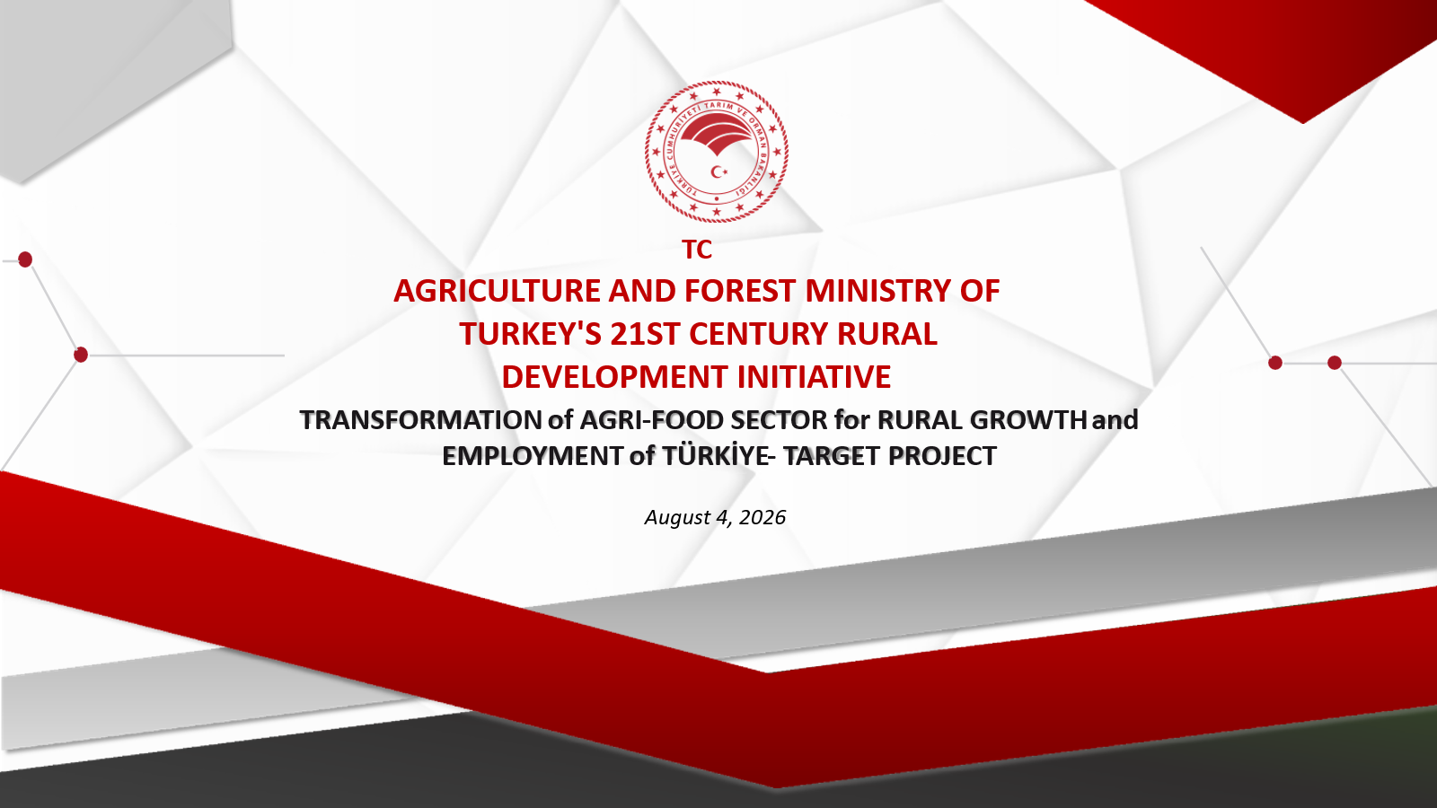

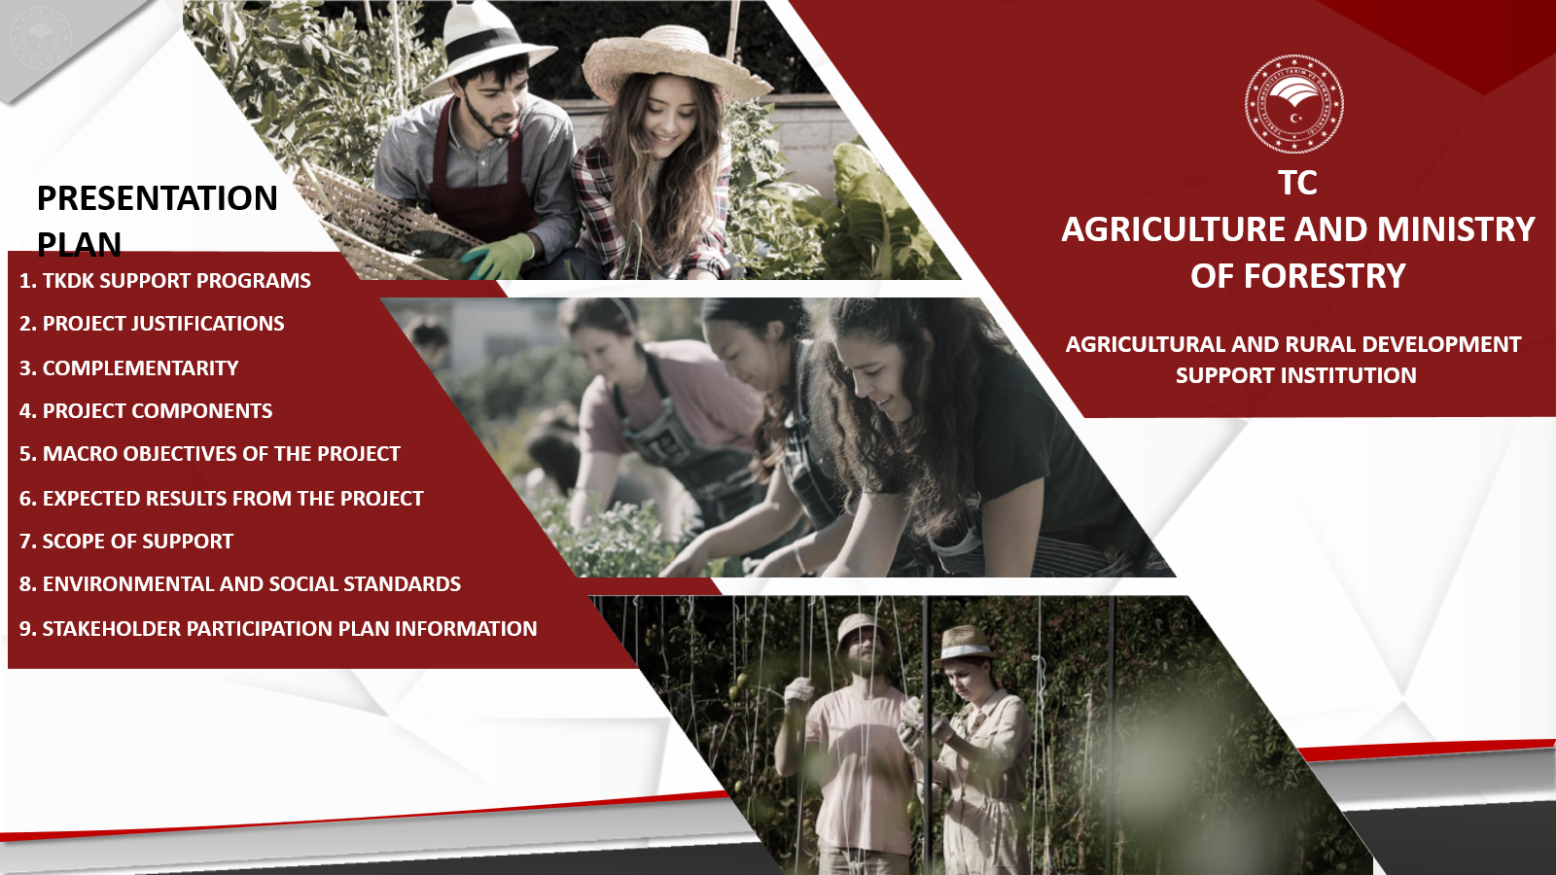

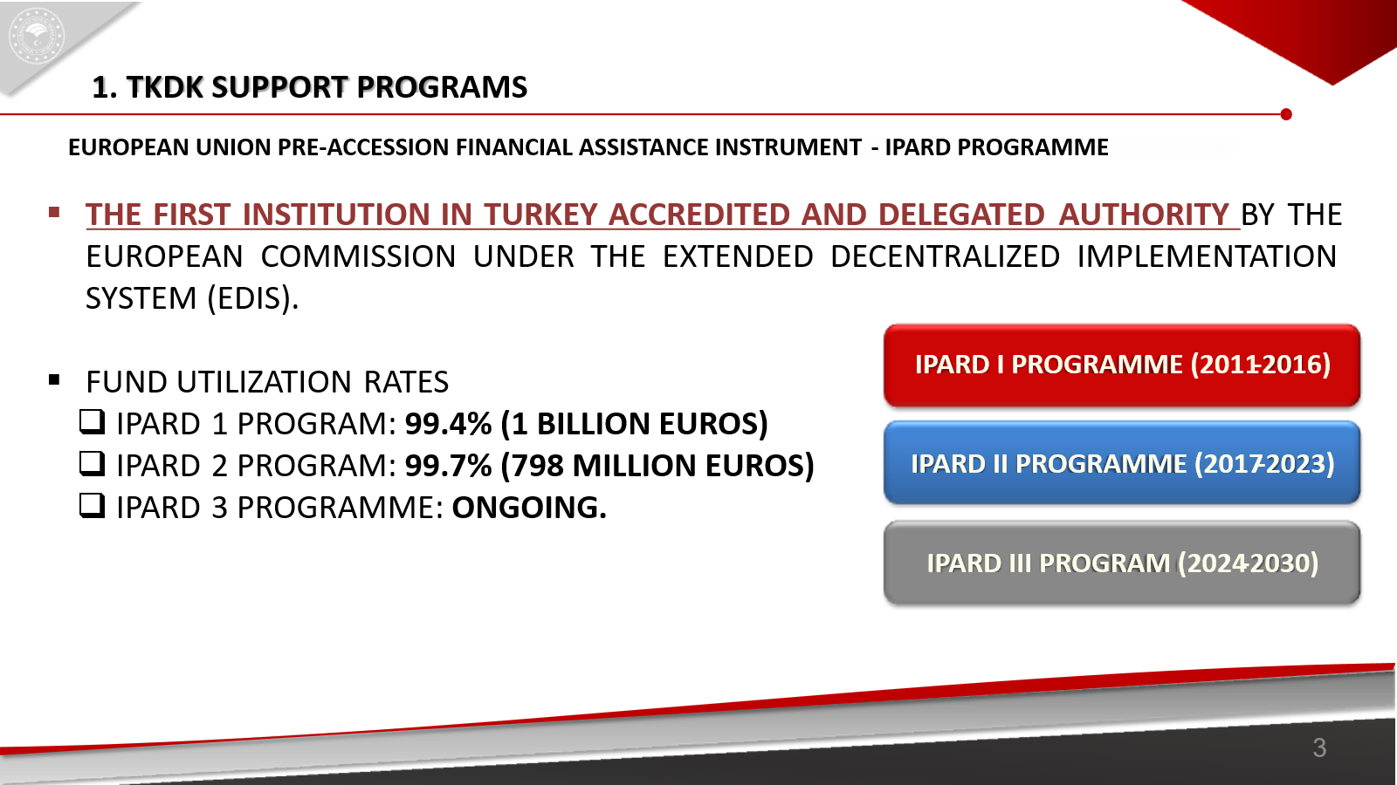
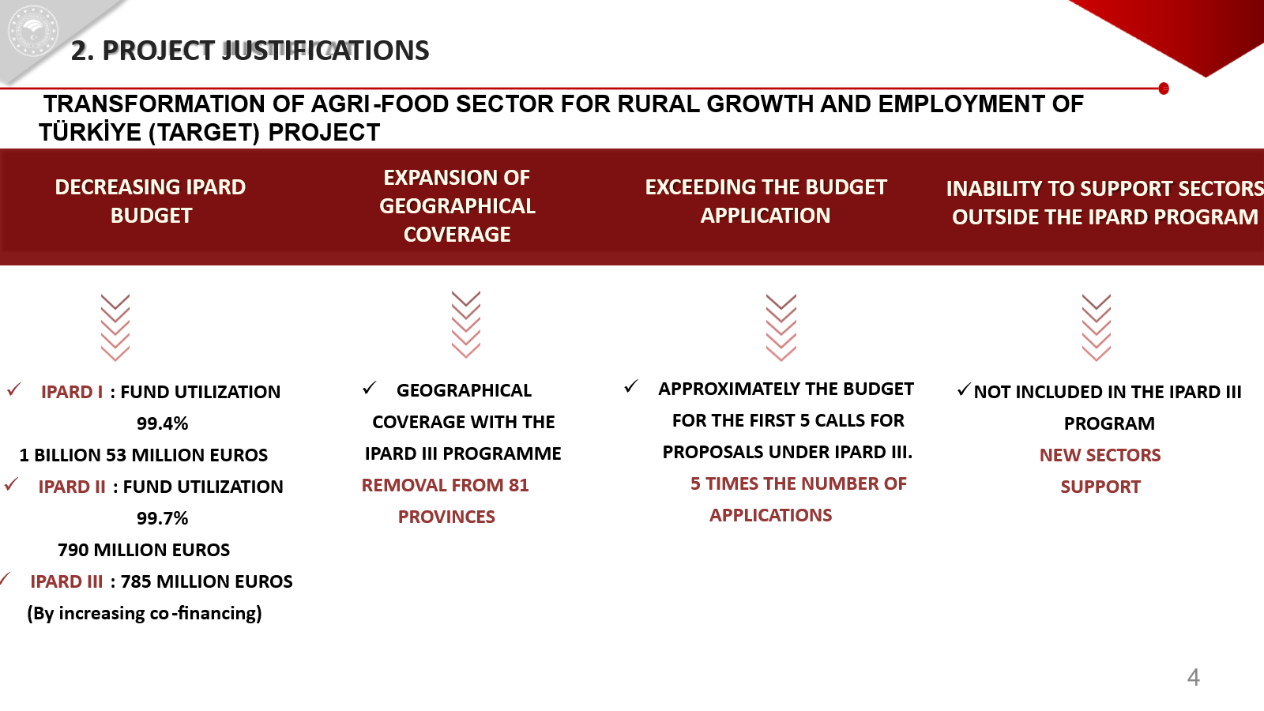

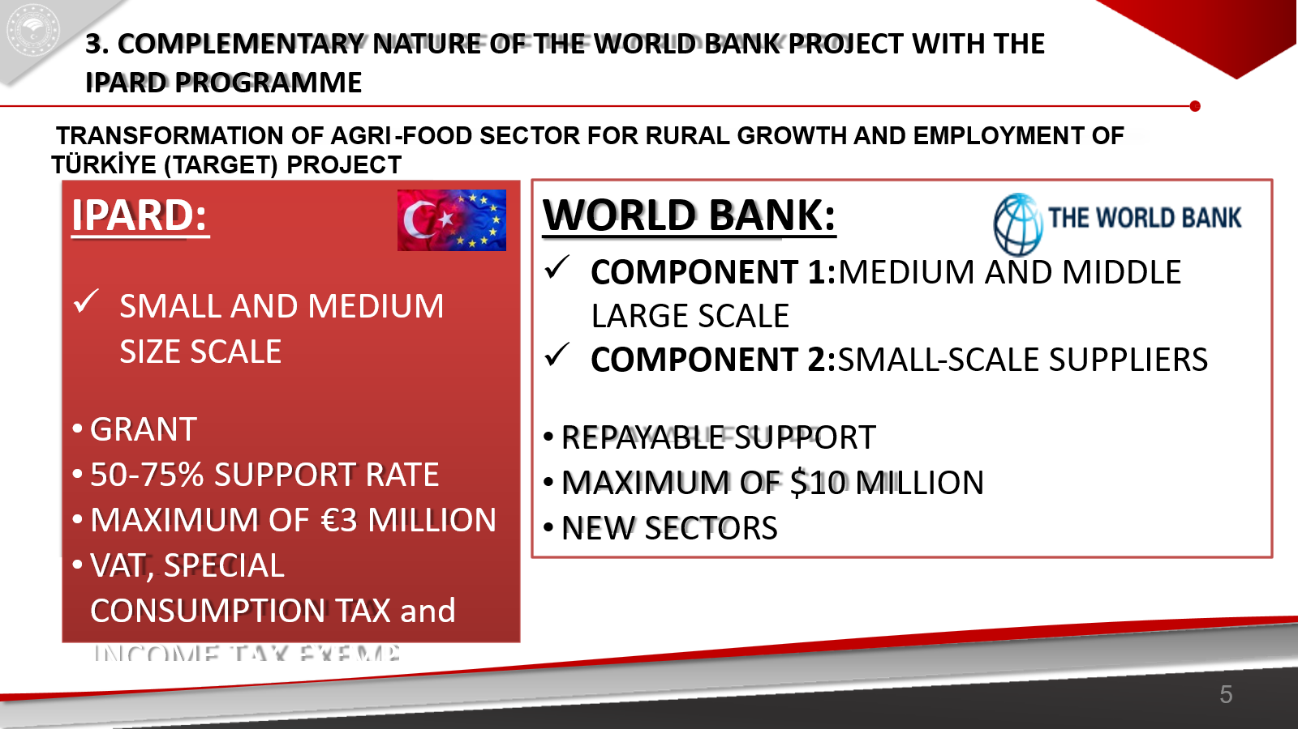

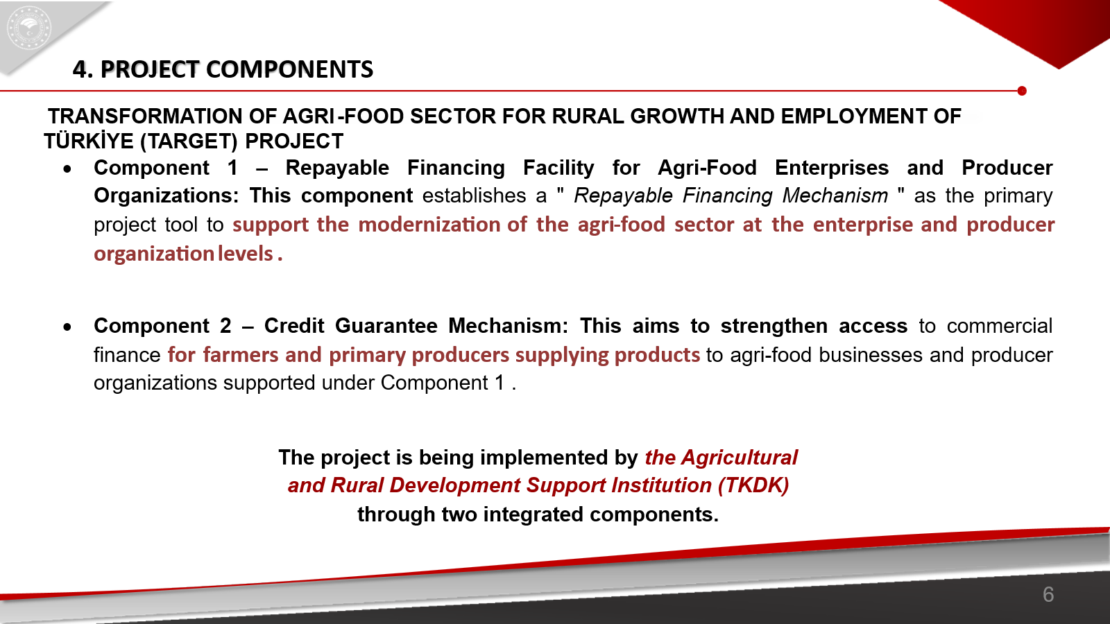

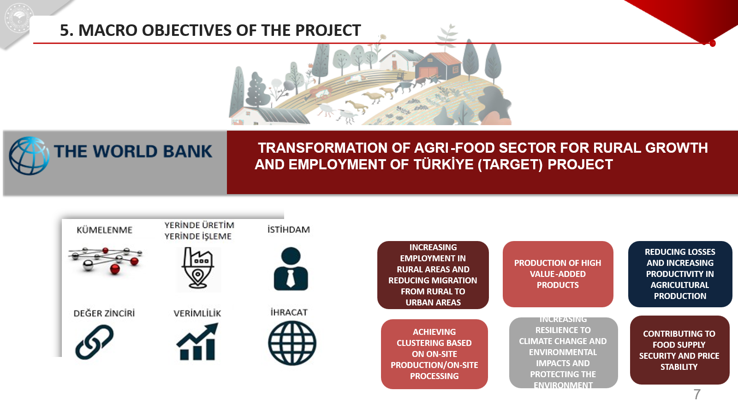

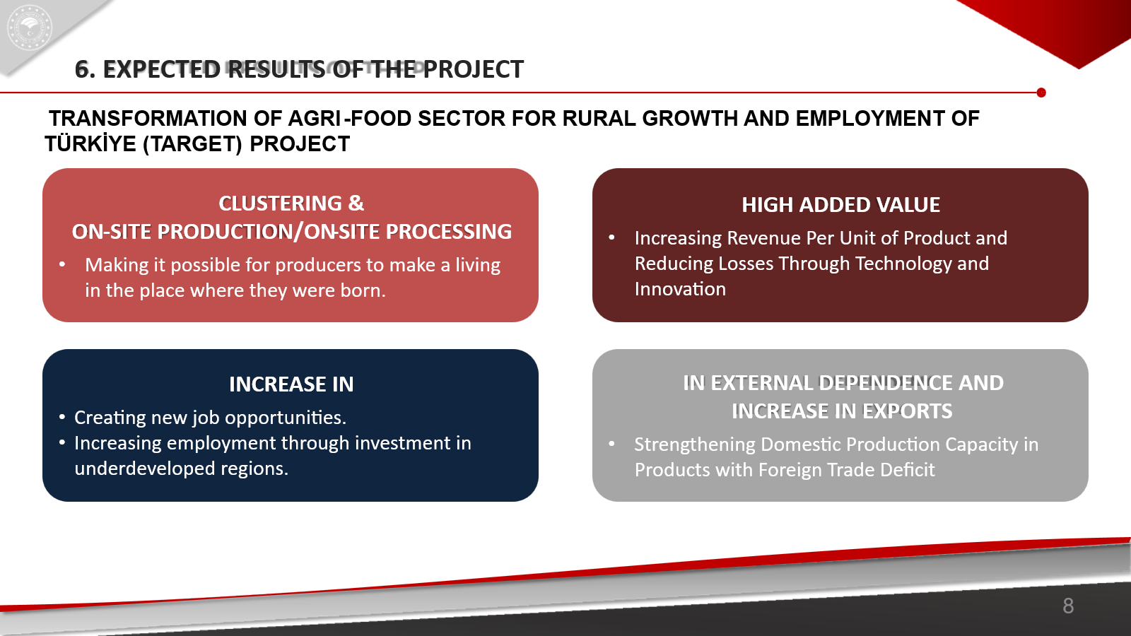
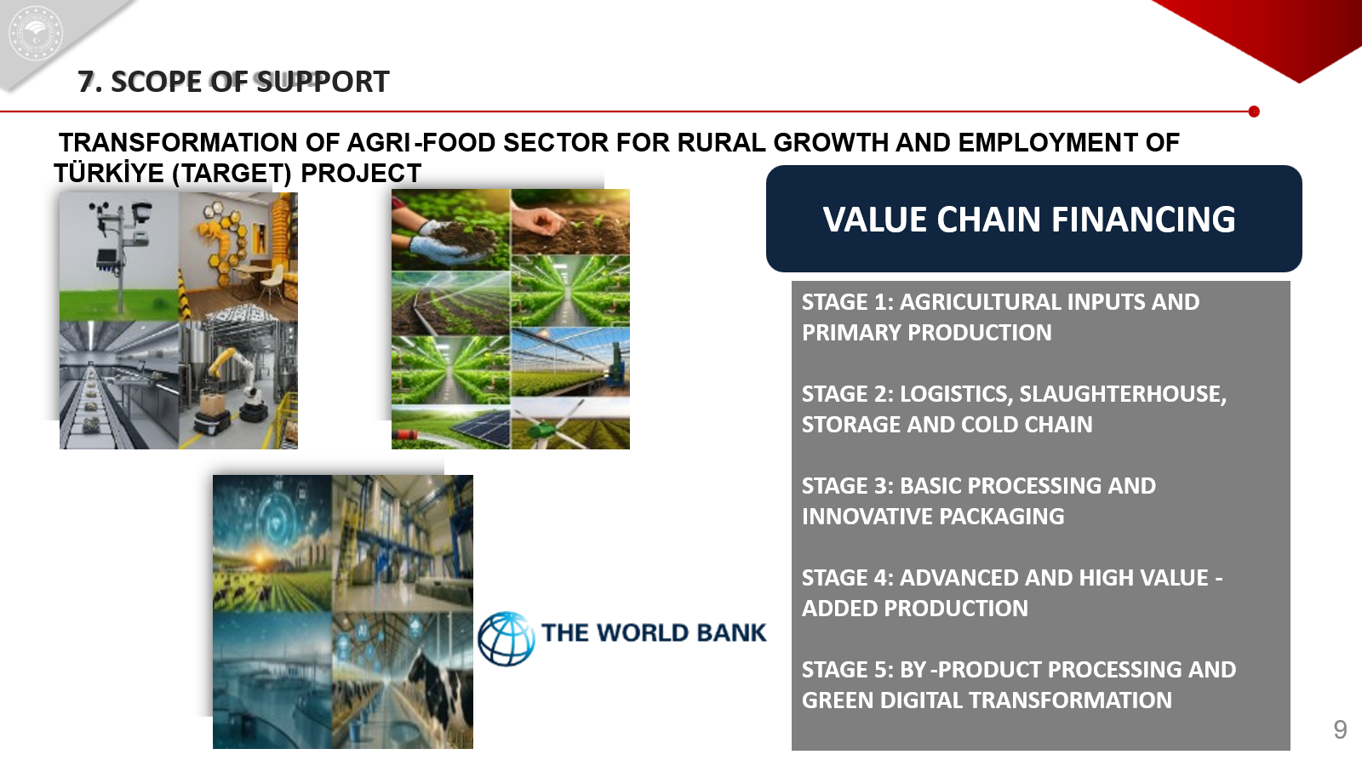
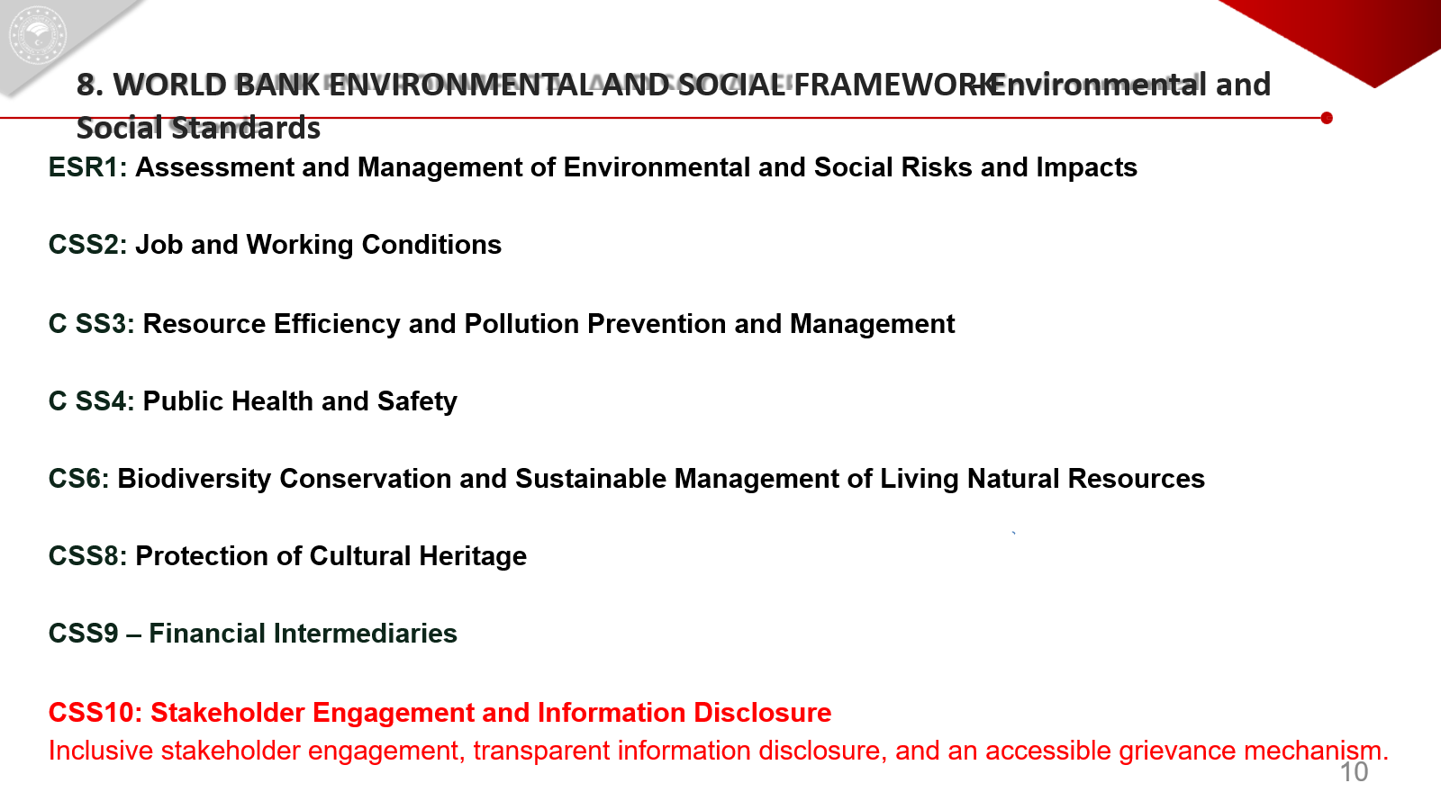

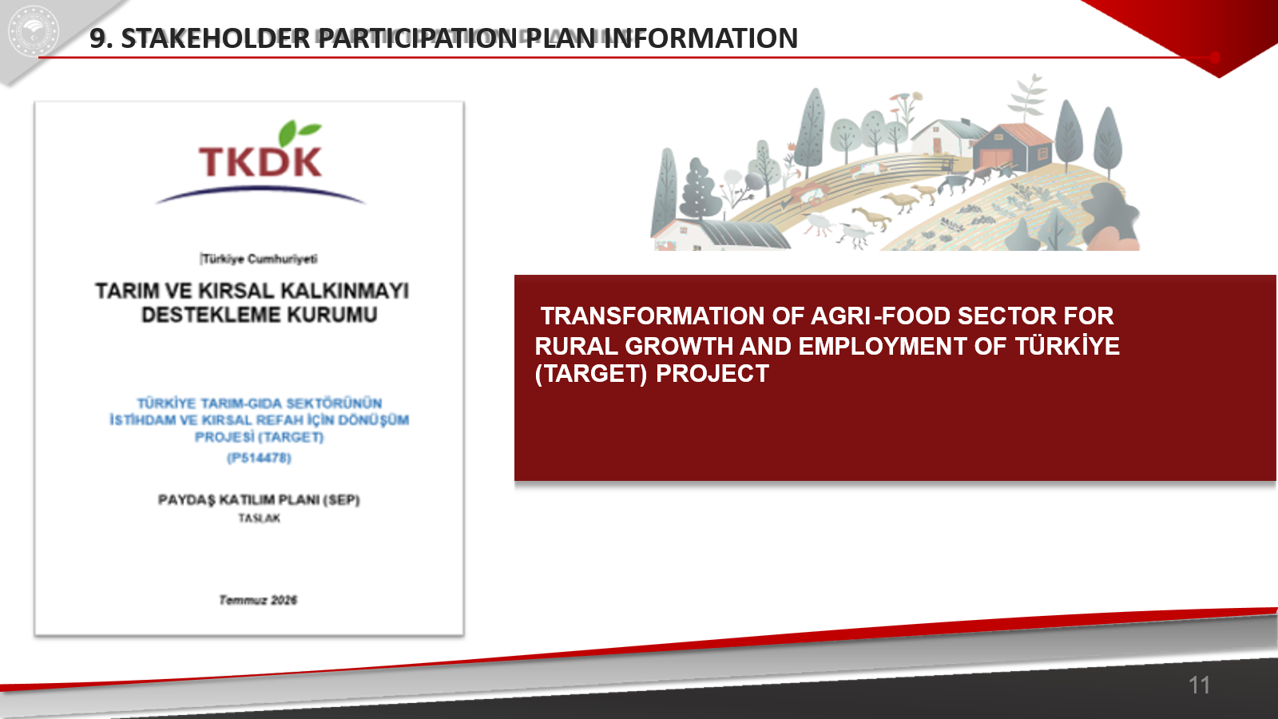

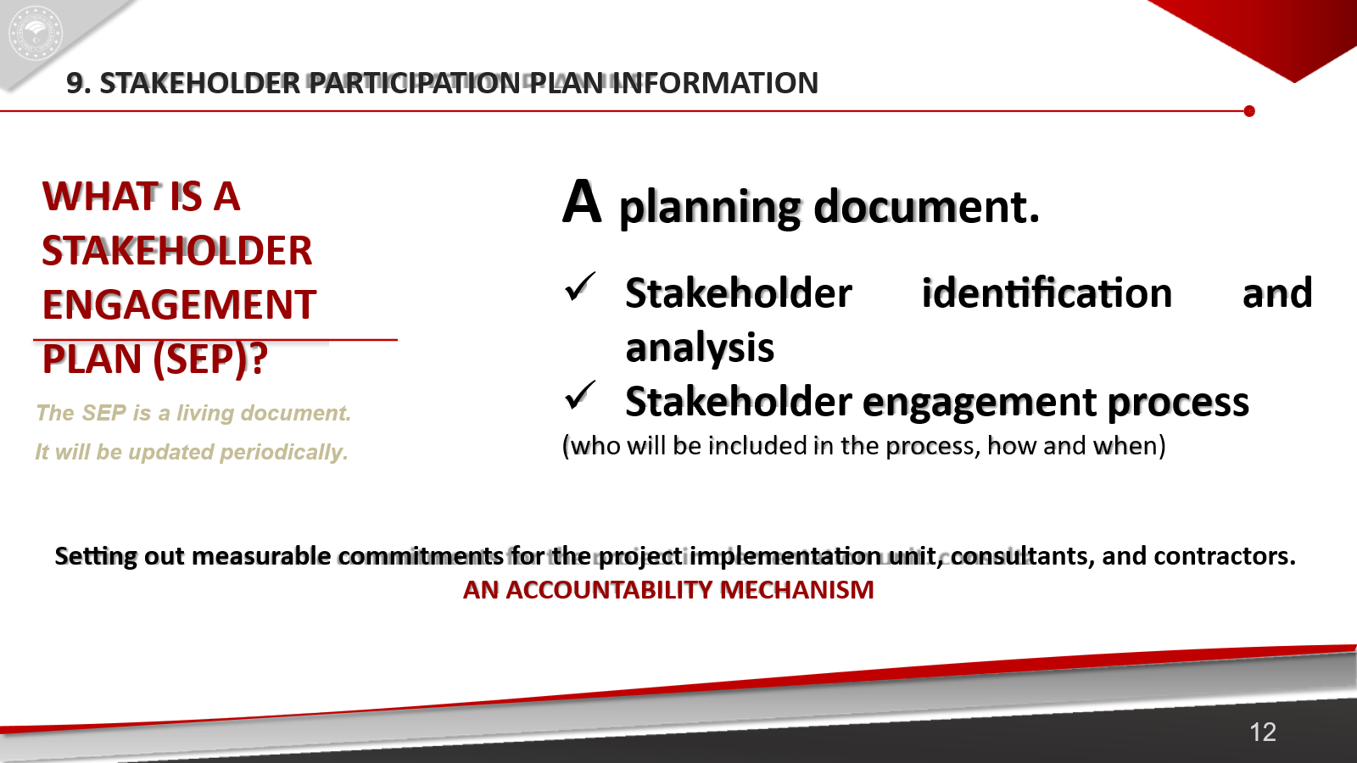

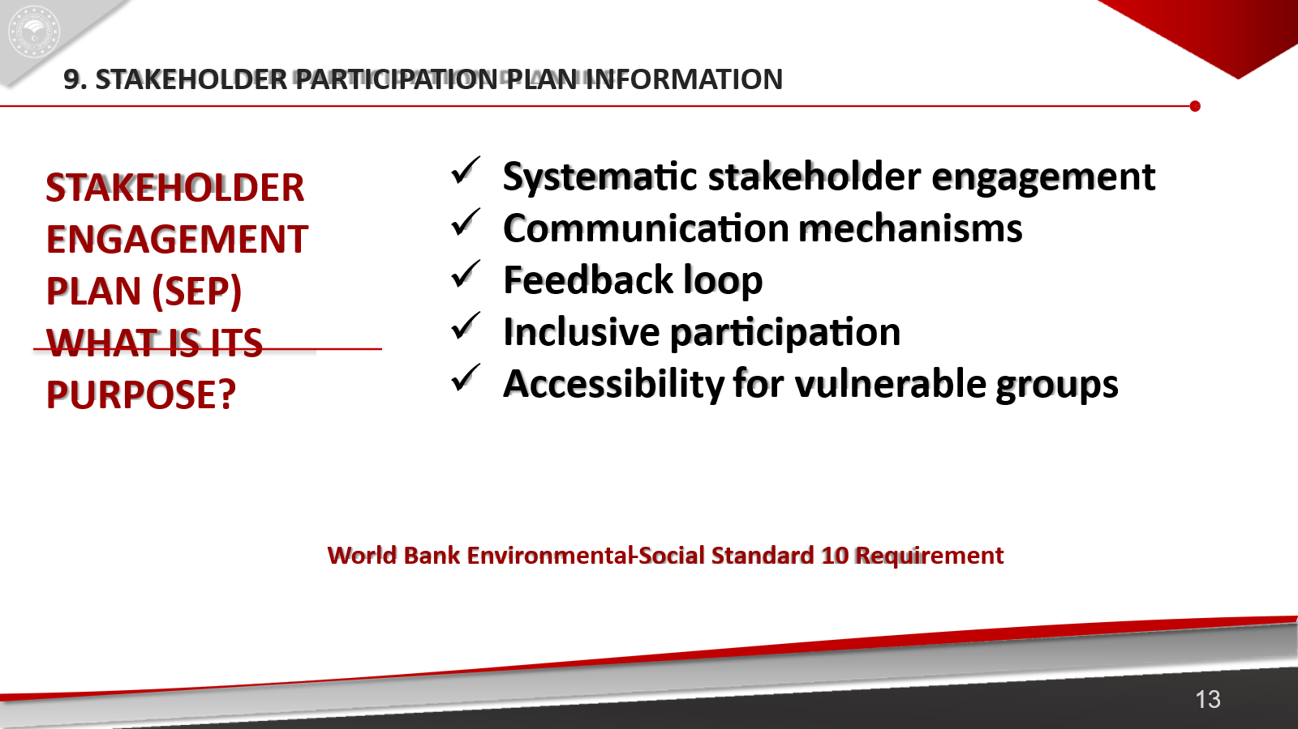
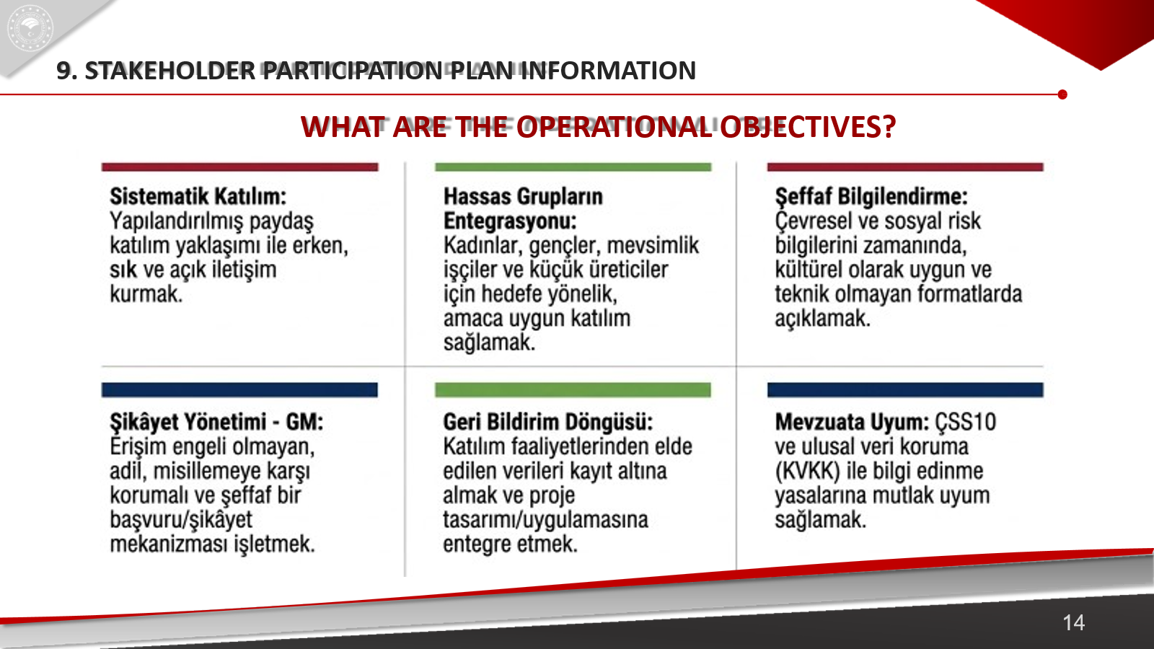
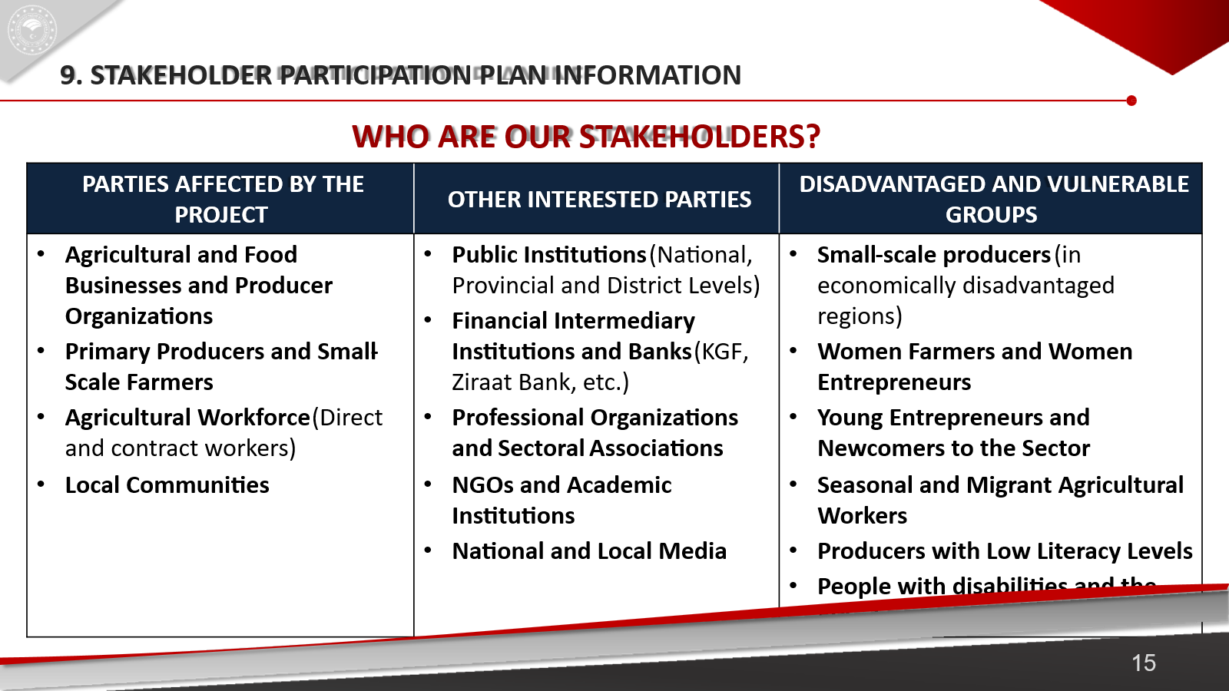
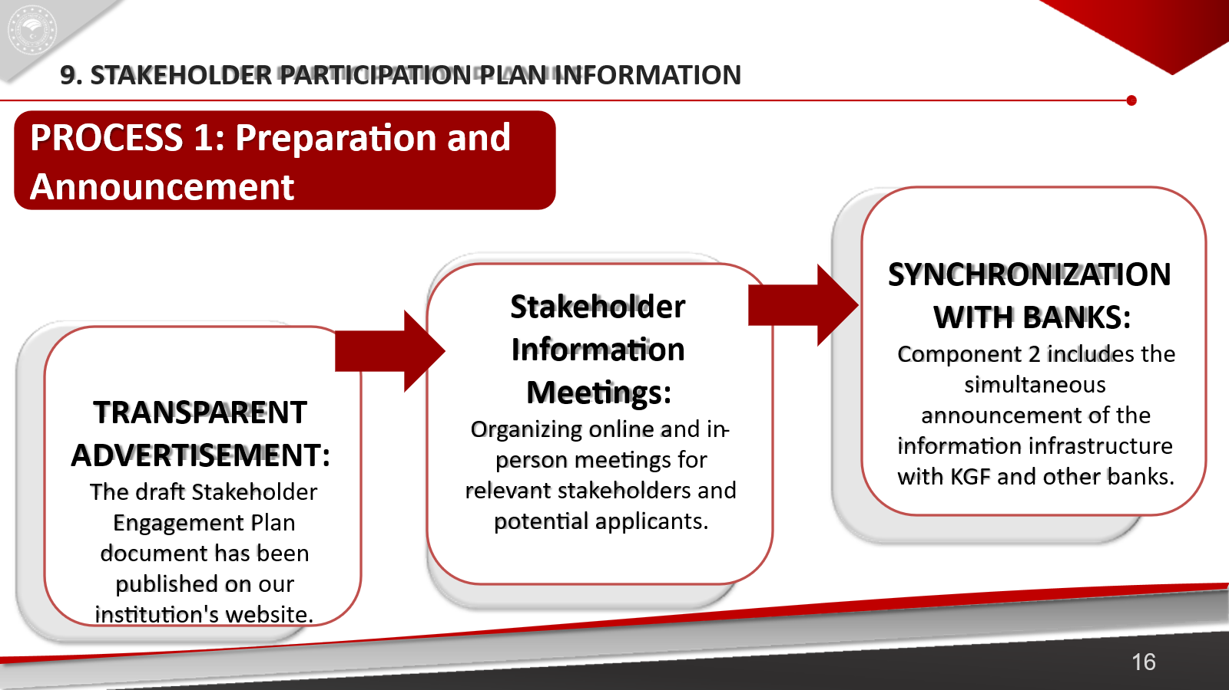
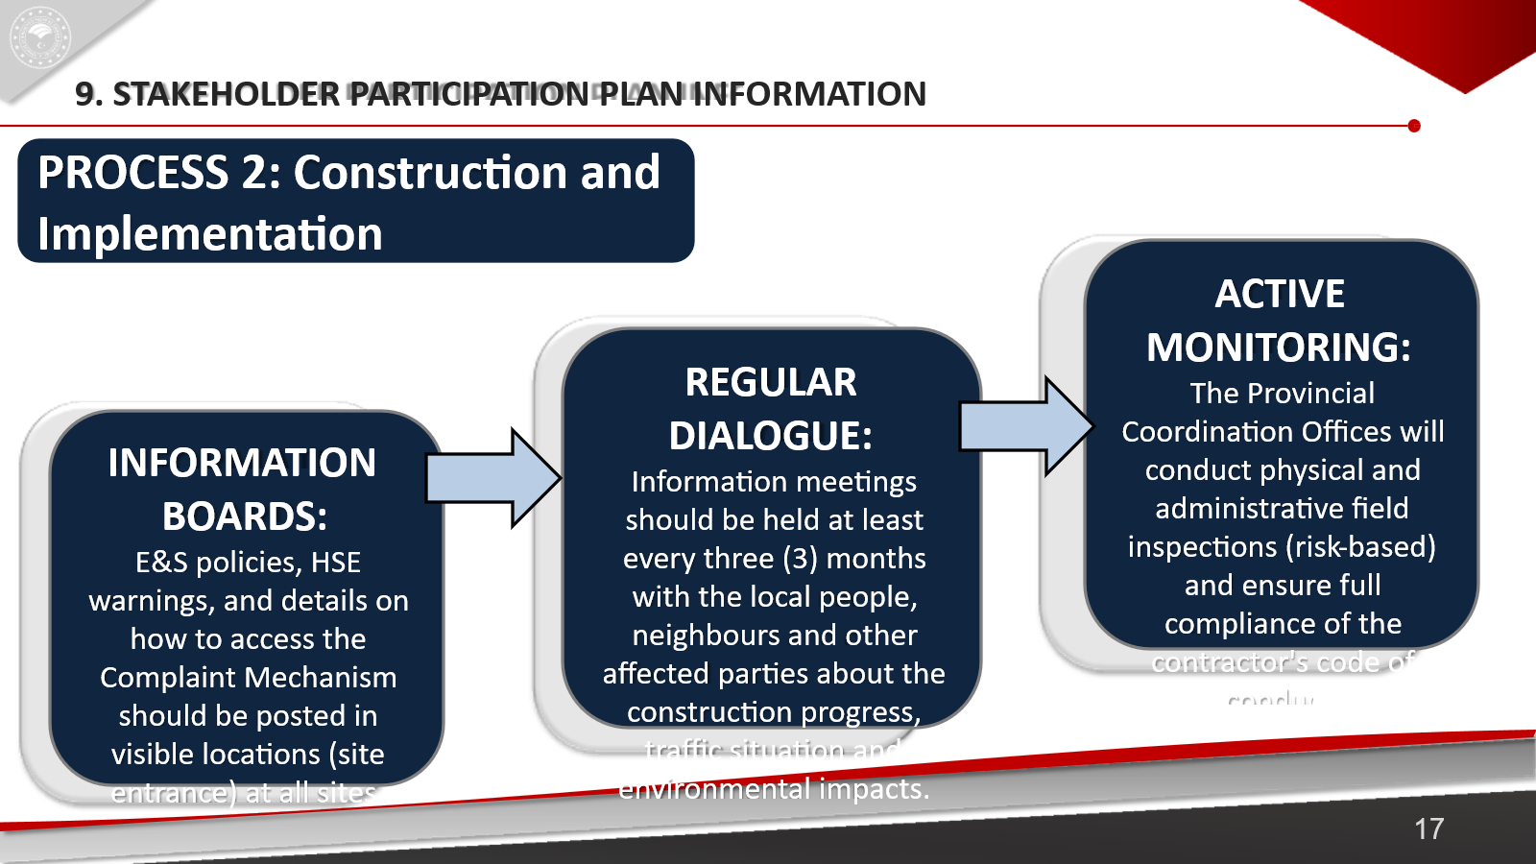
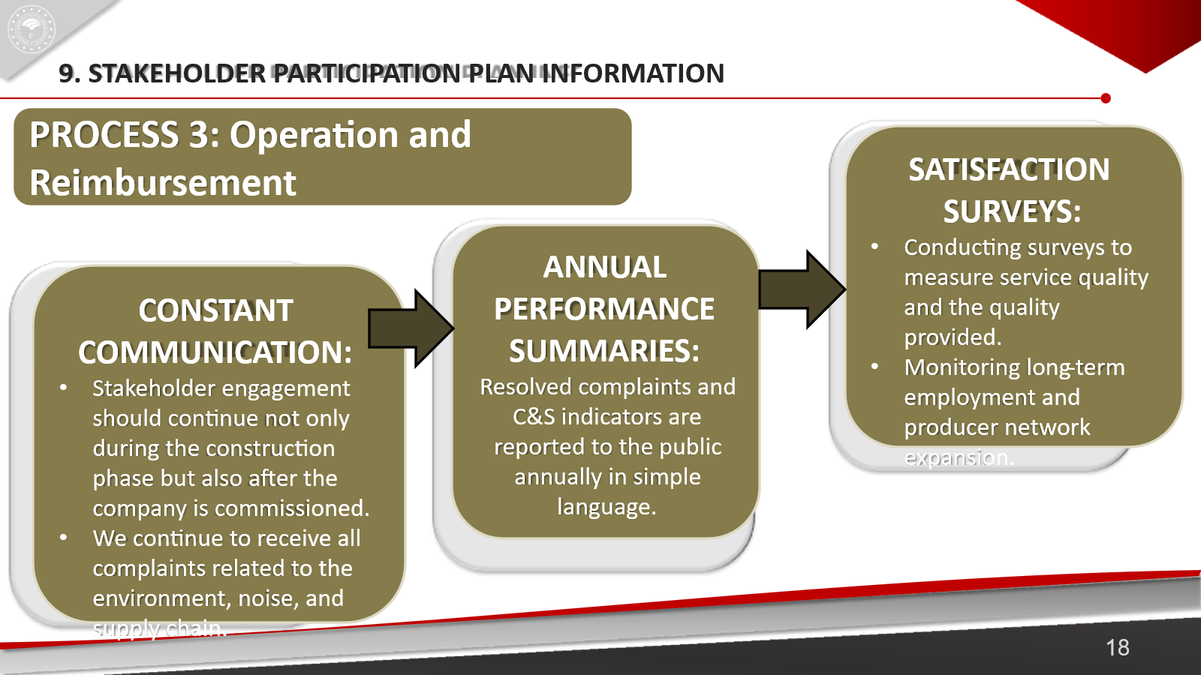

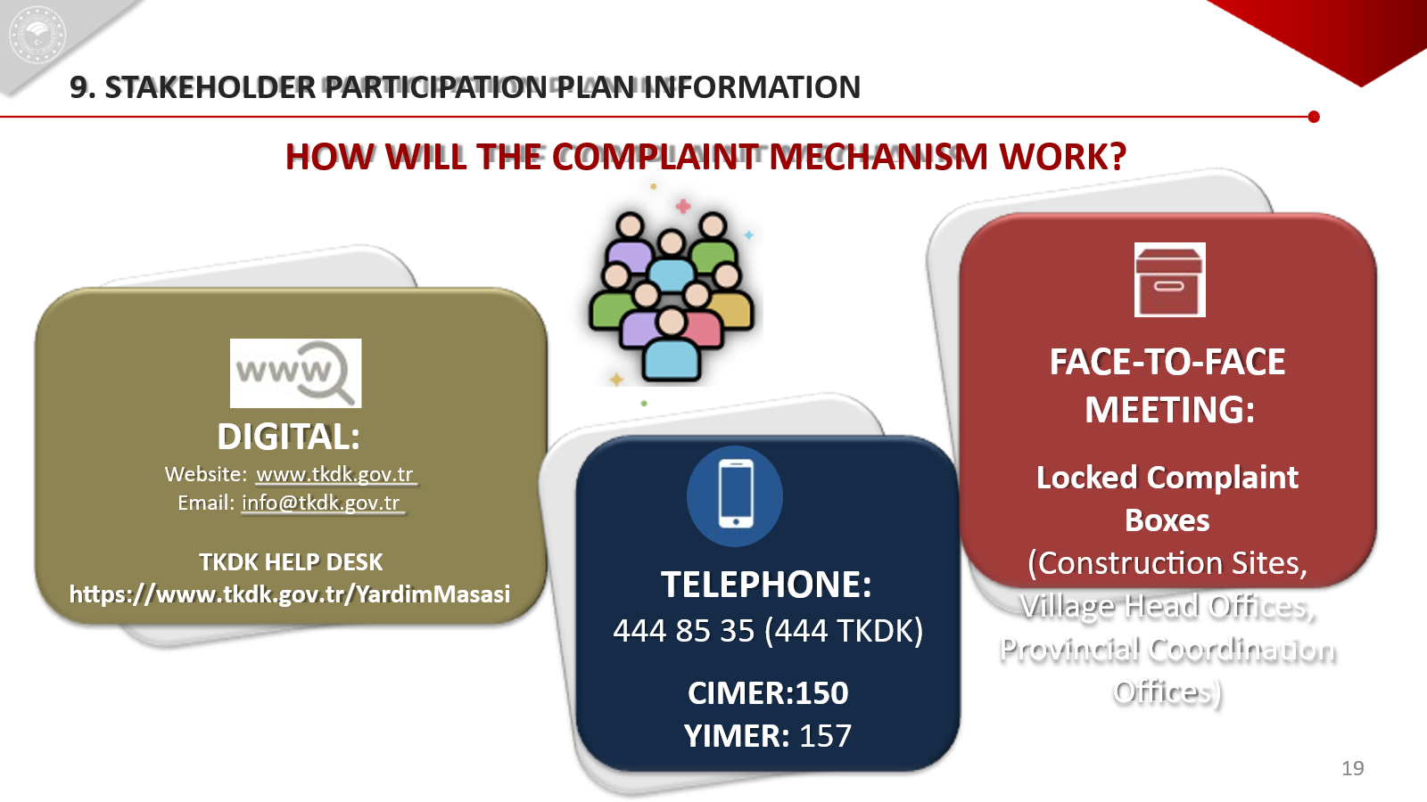
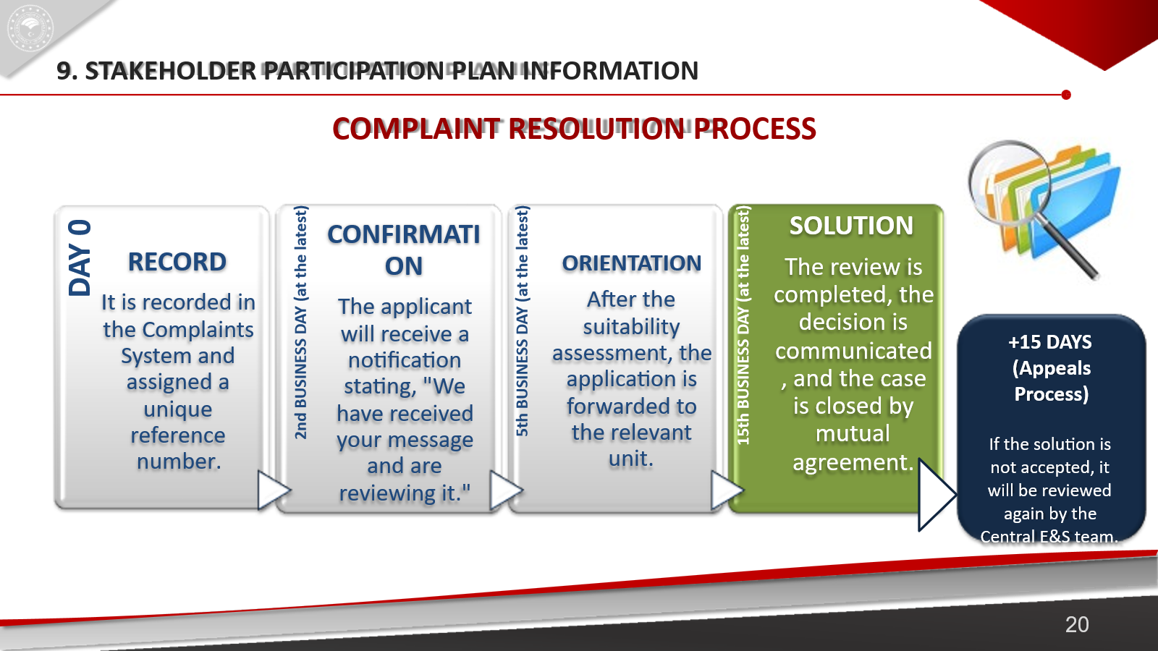

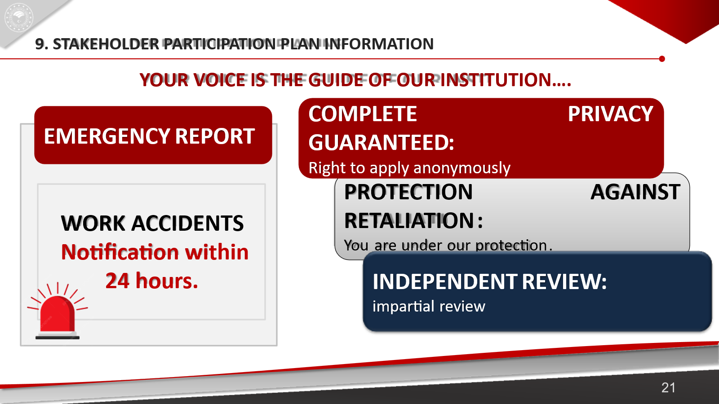
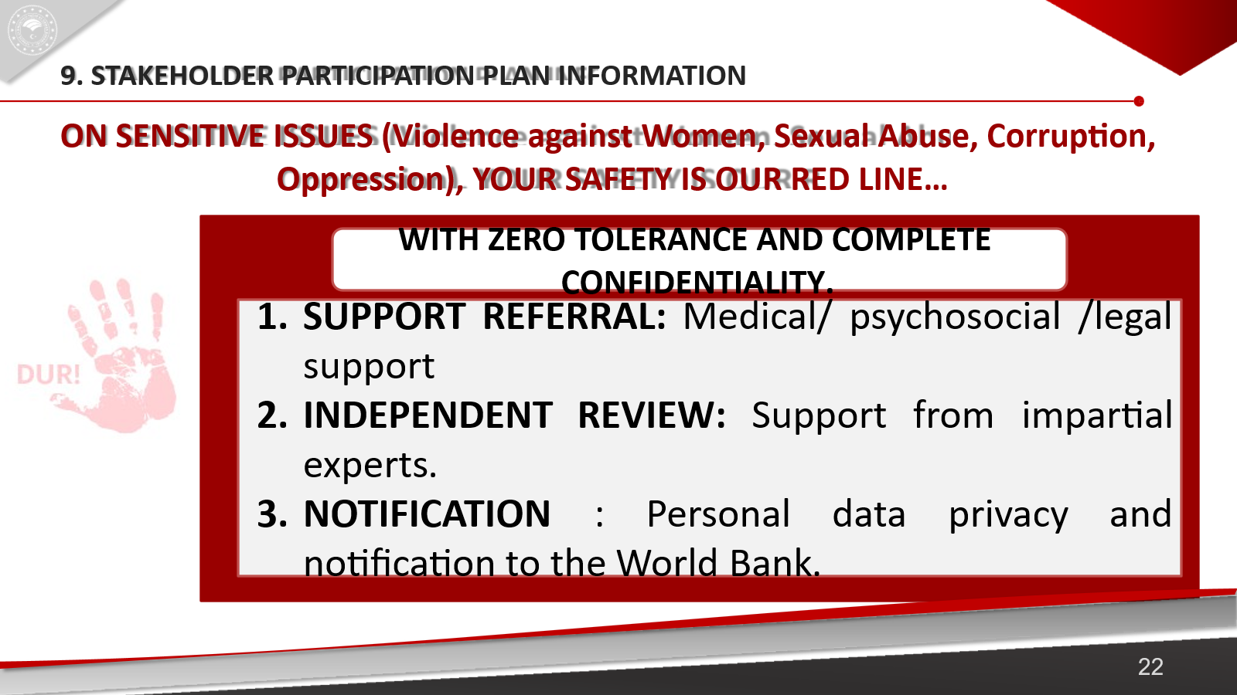
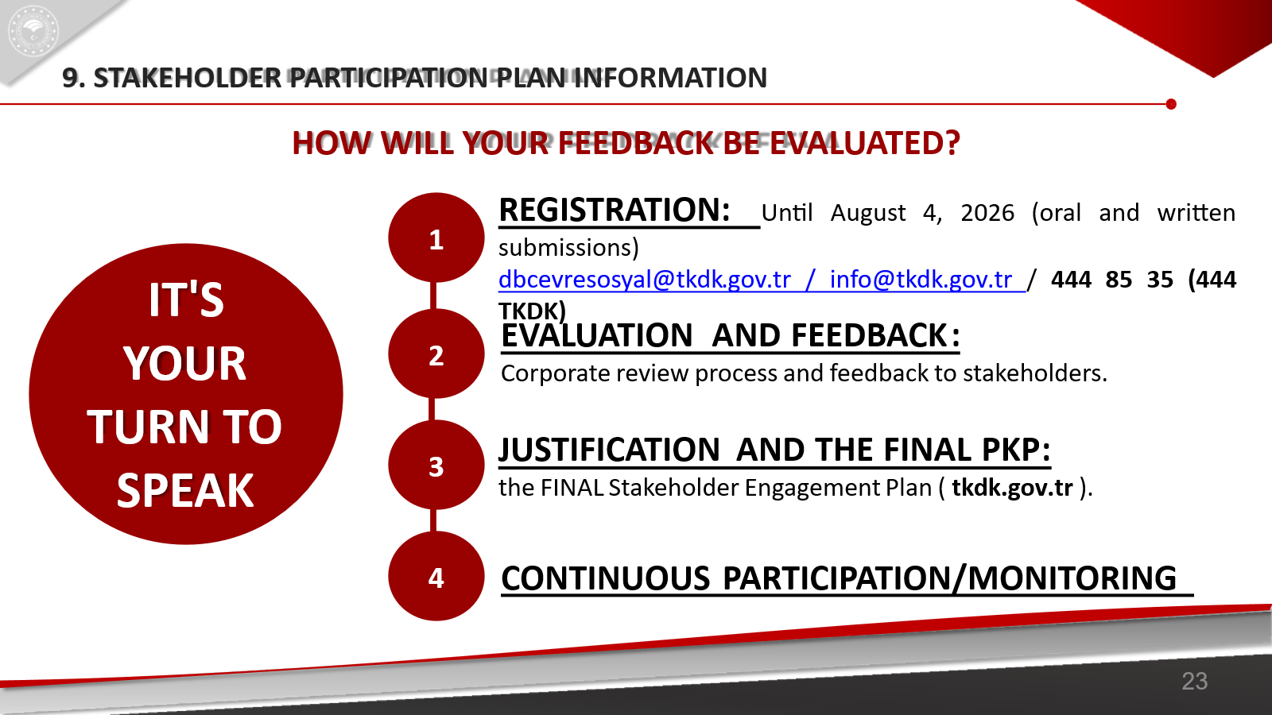

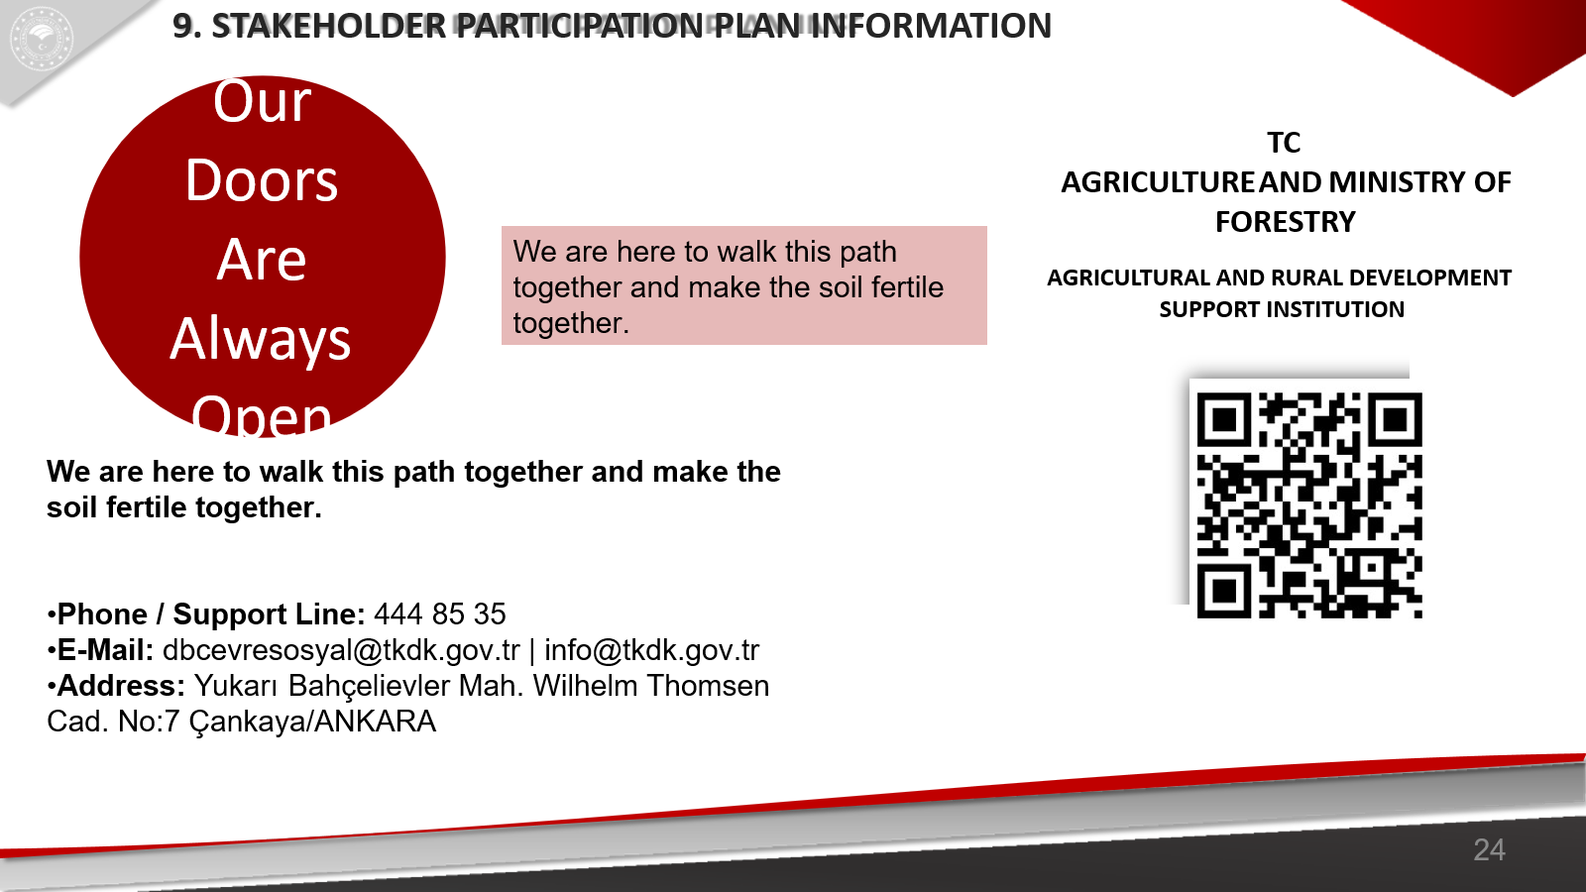

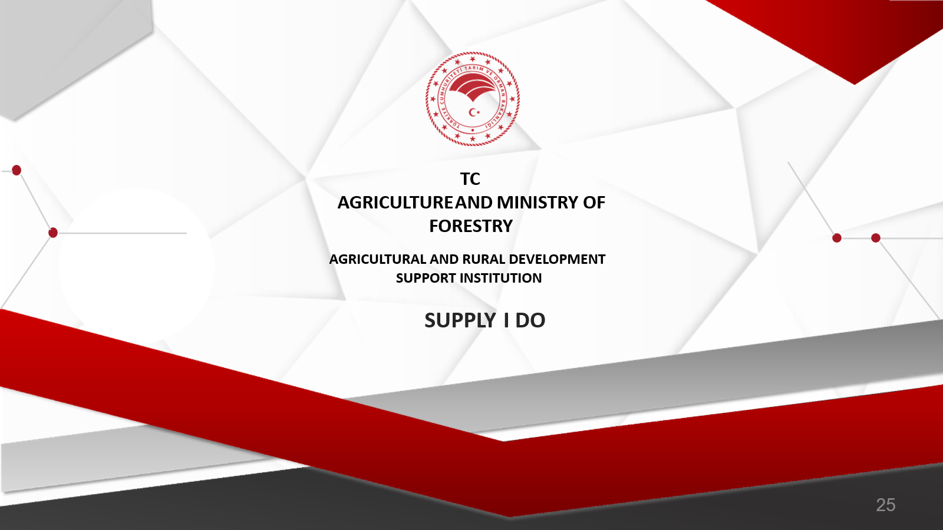

Annex J: Photographs Of The Stakeholder Consultation Meeting (Date: August 4, 2026 / Format: Online)
